**Report**

Name: Nestor Fok

Module code: COMP23111

### Title of assessment: 23111-Cwk2-S-Advanced Databases

### Date: 27/11

### Table of Content

### Normalisation

### Relational schema

### Implementation

### The application

**Part A: Normalization**

**1. Introduction**

This is the process of structuring the database, based on the snippet of the information source. Tables will be created base on the primary key and other attributes. This process will take several steps which is unnormalized normalization form, first normalization form, second normalization form and third normalization form respectively.

**2. Unnormalized normalization form (UNF)**

This is the first step or normalization. This step will transform the information source into a table. This process will not meet any criteria of normalization. I will identify the key of the table as QuizID, StudentID. I have created the table by putting all the information from the information source such as Question and Choice.

|  |  |  |  |
| --- | --- | --- | --- |
| QuizID | 34 | | |
| QuizName | SQL | | |
| QuizAuthor | Peter Parker | | |
| QuizAvailable | Yes | | |
| QuizDuration | 60 minutes | | |
| StudentID | 44 | | |
| StudentName | Duncan Hull | | |
| DateOfAttempt | 22/11/2020 | | |
| QuestionID | 1 | 2 | 3 |
| Question | Which SQL statement is used to extract data from a database? | Which SQL statement is used to insert new data in a database? | With SQL, how do you select all the records from a table named “Persons” where the value of the column “FirstName” is “Peter”? |
| Choice1 | SELECT | INSERT NEW | SELECT * FROM Persons WHERE FIRSTNAME <> ‘Peter’ |
| Choice2 | OPEN | INSERT INTO | SELECT [all] FROM Persons WHERE FIRSTName = ‘Peter’ |
| Choice3 | EXTRACT | ADD RECORD | SELECT * FROM Persons WHERE FIRSTName = ‘Peter’ |
| Choice4 | GET | ADD NEW | SELECT [all] FROM Persons WHERE FIRSTName LIKE ‘Peter’ |
| Answer | SELECT | INSERT INTO | SELECT * FROM Persons WHERE FIRSTName = ‘Peter’ |

**3. First normalization form (1NF)**

To execute this step, firstly I have identified cells that is not atomic which are QuestionID, Question, Choice and Answer. Secondly, I have divided these cells into new table to make them atomic. I have identified the primary key as QuizID, StudentID and DateOfAttempt in the first table and QuizID and QuestionID as the primary key in the second table.

|  |  |
| --- | --- |
| QuizID | 34 |
| QuizName | SQL |
| QuizAuthor | Peter Parker |
| QuizAvailable | Yes |
| QuizDuration | 60 minutes |
| StudentID | 44 |
| StudentName | Duncan Hull |
| DateOfAttempt | 22/11/2020 |

|  |  |
| --- | --- |
| QuizID | 34 |
| QuestionID | 1 |
| Question | Which SQL statement is used to extract data from a database? |
| Choice1 | SELECT |
| Choice2 | OPEN |
| Choice3 | EXTRACT |
| Choice4 | GET |
| Answer | SELECT |

**4. Second normalization form (2NF)**

To execute this step, firstly I identified keys which have partial dependency. QuizName, QuizAuthor, QuizAvailable and QuizDuration have partial dependency with QuizID only. As a result, I separate them out and form the second table with QuizID as primary key. StudentName has partial dependency with StudentID only so I separate it and form the third table with StudentID as primary key. Only DateOfAttempt has dependency with both QuizID and StudentID so I keep it in the original table. Question, Choice and Answer are depended on QuestionID so I separate QuestionID, Question, Choice and Answer into the fifth table with QuestionID as primary key. QuestionID is depended on QuizID so I remain it in the fourth table with QuizID as primary key.

First Table

|  |  |
| --- | --- |
| QuizID | 34 |
| StudentID | 44 |
| DateOfAttempt | 22/11/2020 |

Second Table

|  |  |
| --- | --- |
| QuizID | 34 |
| QuizName | SQL |
| QuizAuthor | Peter Parker |
| QuizAvailable | Yes |
| QuizDuration | 60 minutes |

Third Table

|  |  |
| --- | --- |
| StudentID | 44 |
| StudentName | Duncan Hull |

Fourth Table

|  |  |
| --- | --- |
| QuizID | 34 |
| QuestionID | 1 |

Fifth Table

|  |  |
| --- | --- |
| QuestionID | 1 |
| Question | Which SQL statement is used to extract data from a database? |
| Choice1 | SELECT |
| Choice2 | OPEN |
| Choice3 | EXTRACT |
| Choice4 | GET |
| Answer | SELECT |

**5. Third normalization form (3NF)**

To execute this step, Firstly, I identified keys which are not transitive dependent. Answer is depended on table so I separate Answer, Choice into the sixth table with QuizID as the primary key.

**First Table**

|  |  |
| --- | --- |
| QuizID | 34 |
| StudentID | 44 |
| DateOfAttempt | 22/11/2020 |

**Second Table**

|  |  |
| --- | --- |
| QuizID | 34 |
| QuizName | SQL |
| QuizAuthor | Peter Parker |
| QuizAvailable | Yes |
| QuizDuration | 60 minutes |

**Third Table**

|  |  |
| --- | --- |
| StudentID | 44 |
| StudentName | Duncan Hull |

**Fourth Table**

|  |  |
| --- | --- |
| QuizID | 34 |
| QuestionID | 1 |

**Fifth Table**

|  |  |
| --- | --- |
| QuestionID | 1 |
| Question | Which SQL statement is used to extract data from a database? |

**Sixth Table**

|  |  |
| --- | --- |
| QuestionID | 1 |
| Choice1 | SELECT |
| Choice2 | OPEN |
| Choice3 | EXTRACT |
| Choice4 | GET |
| Answer | SELECT |

**Part B: Relational Schema**

**1. Introduction**

In relation schema, I will create several tables for the database and show the relation between them. The table will be in 3 columns which show the field, data type and constraints. Next will be the ER diagram which show the relation between each table.

**2. Schema**

Student

|  |  |  |
| --- | --- | --- |
| Field | Data Type | Constraints |
| studentID | INT | Unsigned, 0-4294967295, primary key |
| studentName | Varchar | 50 Characters, not null |
| username | Varchar | 50 Characters, not null |
| password | Varchar | 50 Characters, not null |

Staff

|  |  |  |
| --- | --- | --- |
| Field | Data Type | Constraints |
| staffID | INT | Unsigned, 0-4294967295, primary key |
| username | Varchar | 50 Characters, not null |
| staffName | Varchar | 50 Characters, not null |

Quiz

|  |  |  |
| --- | --- | --- |
| Field | Data Type | Constraints |
| quizID | INT | Unsigned, 0-4294967295, primary key |
| quizName | Varchar | 50 Characters, not null |
| quizAuthor | Varchar | 50 Characters, not null |
| quizAvailable | INT | Unsigned, 0-2, not null |
| quizDuration | INT | Unsigned, 0-15 |
| staffID | INT | Unsigned, 0-11, foreign key |

Question

|  |  |  |
| --- | --- | --- |
| Field | Data Type | Constraints |
| questionID | INT | Unsigned, 0-4294967295, primary key |
| content | Text | Not null |
| quizID | INT | Unsigned, 0-4294967295, foreign key |

Choice

|  |  |  |
| --- | --- | --- |
| Field | Data Type | Constraints |
| choiceID | INT | Unsigned, 0-4294967295, primary key |
| choiceContent | Varchar | 1000 Characters, not null |
| answer | INT | Unsigned, 0-2, not null |
| questionID | INT | Unsigned, 0-4294967295, foreign key |

Record

|  |  |  |
| --- | --- | --- |
| Field | Data Type | Constraints |
| recordID | INT | Unsigned, 0-4294967295, primary key |
| studentID | INT | Unsigned, 0-4294967295, foreign key |
| quizID | INT | Unsigned, 0-4294967295, foreign key |
| dateOfAttempt | Date | Not null |
| grade | INT | 0-50, not null |

ER Diagram

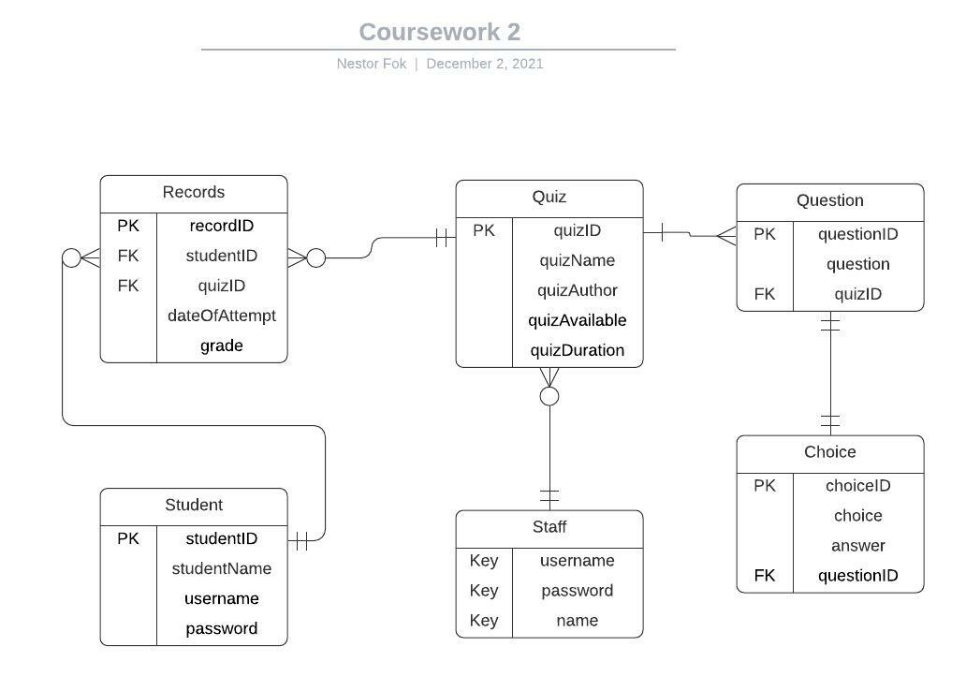

**Part C: Implementation**

**1. Introduction to Section**

This is the section which I turn part B into MYSQL code. I have created 6 tables with field, datatype and constraints the same as above.

**2. MySQL Statements used to implement your schema**

CREATE TABLE student (

studentID INT NOT NULL PRIMARY KEY,

studentName VARCHAR(50) NOT NULL,

username VARCHAR(50) NOT NULL,

password VARCHAR(50) NOT NULL

);

CREATE TABLE staff (

staffID INT NOT NULL PRIMARY KEY,

username VARCHAR(50) NOT NULL,

password VARCHAR(50) NOT NULL,

staffName VARCHAR(50) NOT NULL

);

CREATE TABLE quiz (

quizID INT NOT NULL PRIMARY KEY,

quizName VARCHAR(50) NOT NULL,

quizAuthor VARCHAR(50) NOT NULL,

quizAvailable INT(2) NOT NULL,

quizDuration INT(15) NOT NULL,

staffID INT NOT NULL,

FOREIGN KEY (staffID) REFERENCES staff(staffID)

);

CREATE TABLE question (

questionID INT NOT NULL PRIMARY KEY,

content VARCHAR(50) NOT NULL,

quizID INT NOT NULL,

FOREIGN KEY (quizID) REFERENCES quiz(quizID)

);

CREATE TABLE choice (

choiceID INT NOT NULL PRIMARY KEY,

choiceContent VARCHAR(1000) NOT NULL,

answer INT(2) NOT NULL,

questionID INT NOT NULL,

FOREIGN KEY (questionID) REFERENCES question(questionID)

);

CREATE TABLE record (

recordID INT NOT NULL PRIMARY KEY,

studentID INT NOT NULL,

quizID INT NOT NULL,

dateOfAttempt DATE NOT NULL,

grade INT(50) NOT NULL,

FOREIGN KEY (studentID) REFERENCES student(studentID),

FOREIGN KEY (quizID) REFERENCES quiz(quizID)

);

**Part D: The Application**

**1. Introduction to Section**

This is the section which will demonstrate how to use the website, such as registering and logging in. Photos will be included to let user understand easily.

**2. User guide on how to use your application, you may wish to include screenshots.**

**2.1 Student user**

**2.1.1 First page(firstpage.php)**

Firstly, you will be directed to the firstpage.php, which is the first page of the website. In here, you can choose the 3 services. Firstly, you can choose to login as student (Press the ‘Login’ button). Secondly, you can choose to register an account as student. (Press the ‘Register’ button). Thirdly, you can choose to login as staff (Press the ‘Staff Login’ button).

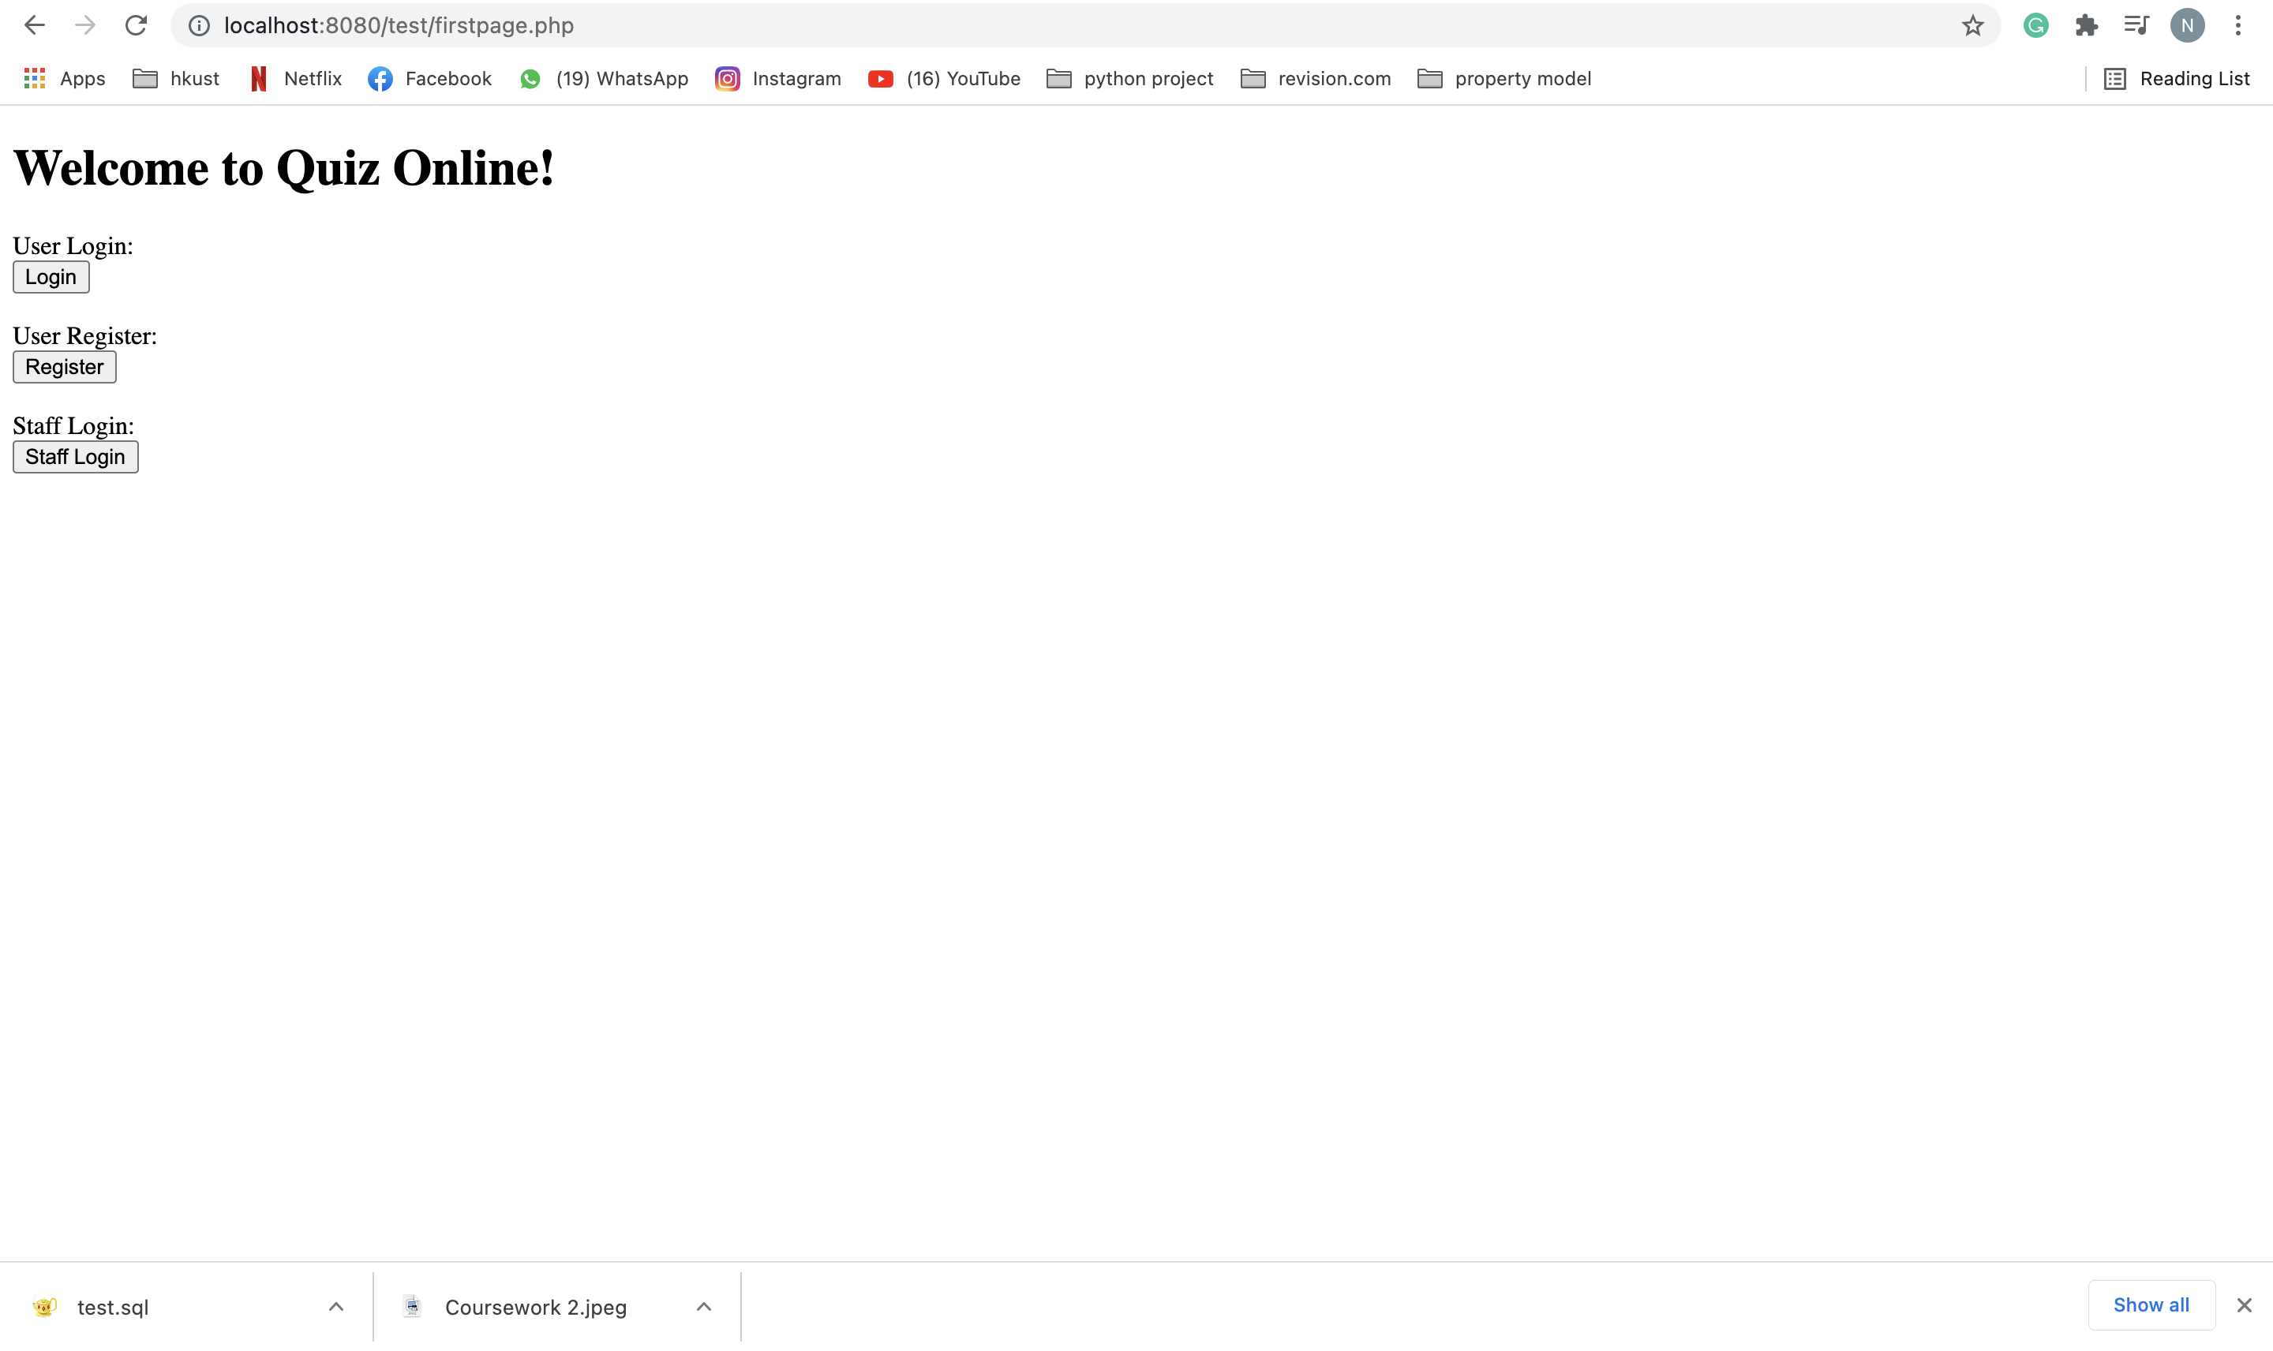

**2.1.2 Register page(register.php)**

This is the page which you can register an account as student. You can type your username, password and name. After you finished, you can press the ‘Register’ button and register the account. The program will help you to detect whether any other people use your username and may require you to type a new username if it is used. The program will also detect whether your password meet the requirement (> 8 characters). If all the requirement is meet, it will show a ‘Success!’ (Refer to the photo 2) and your account is registered. You can press ‘Back to home’ button to return to the first page.

**Photo 1**

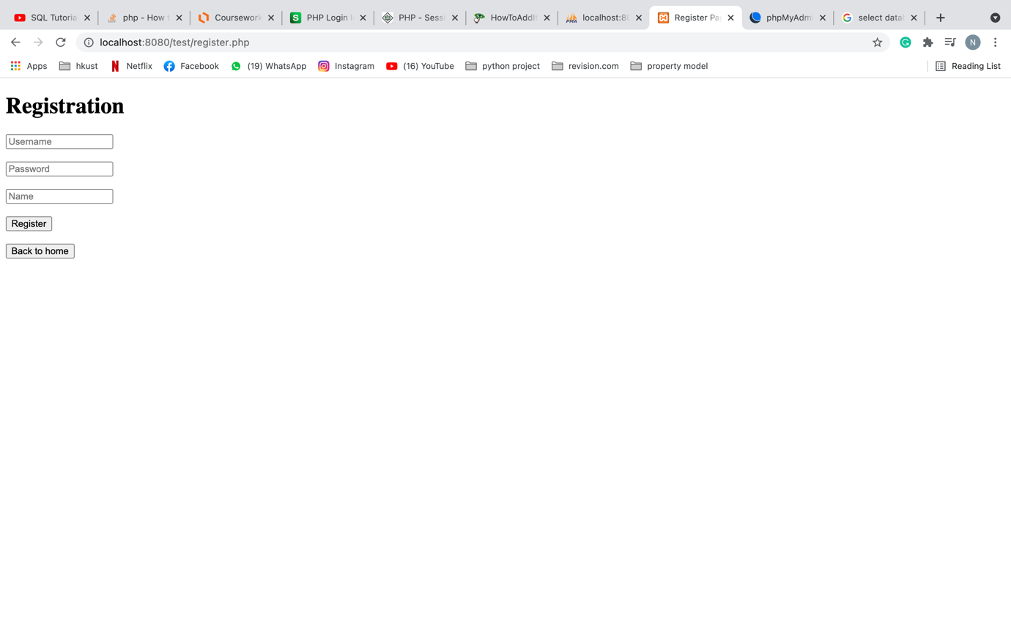

**Photo 2**

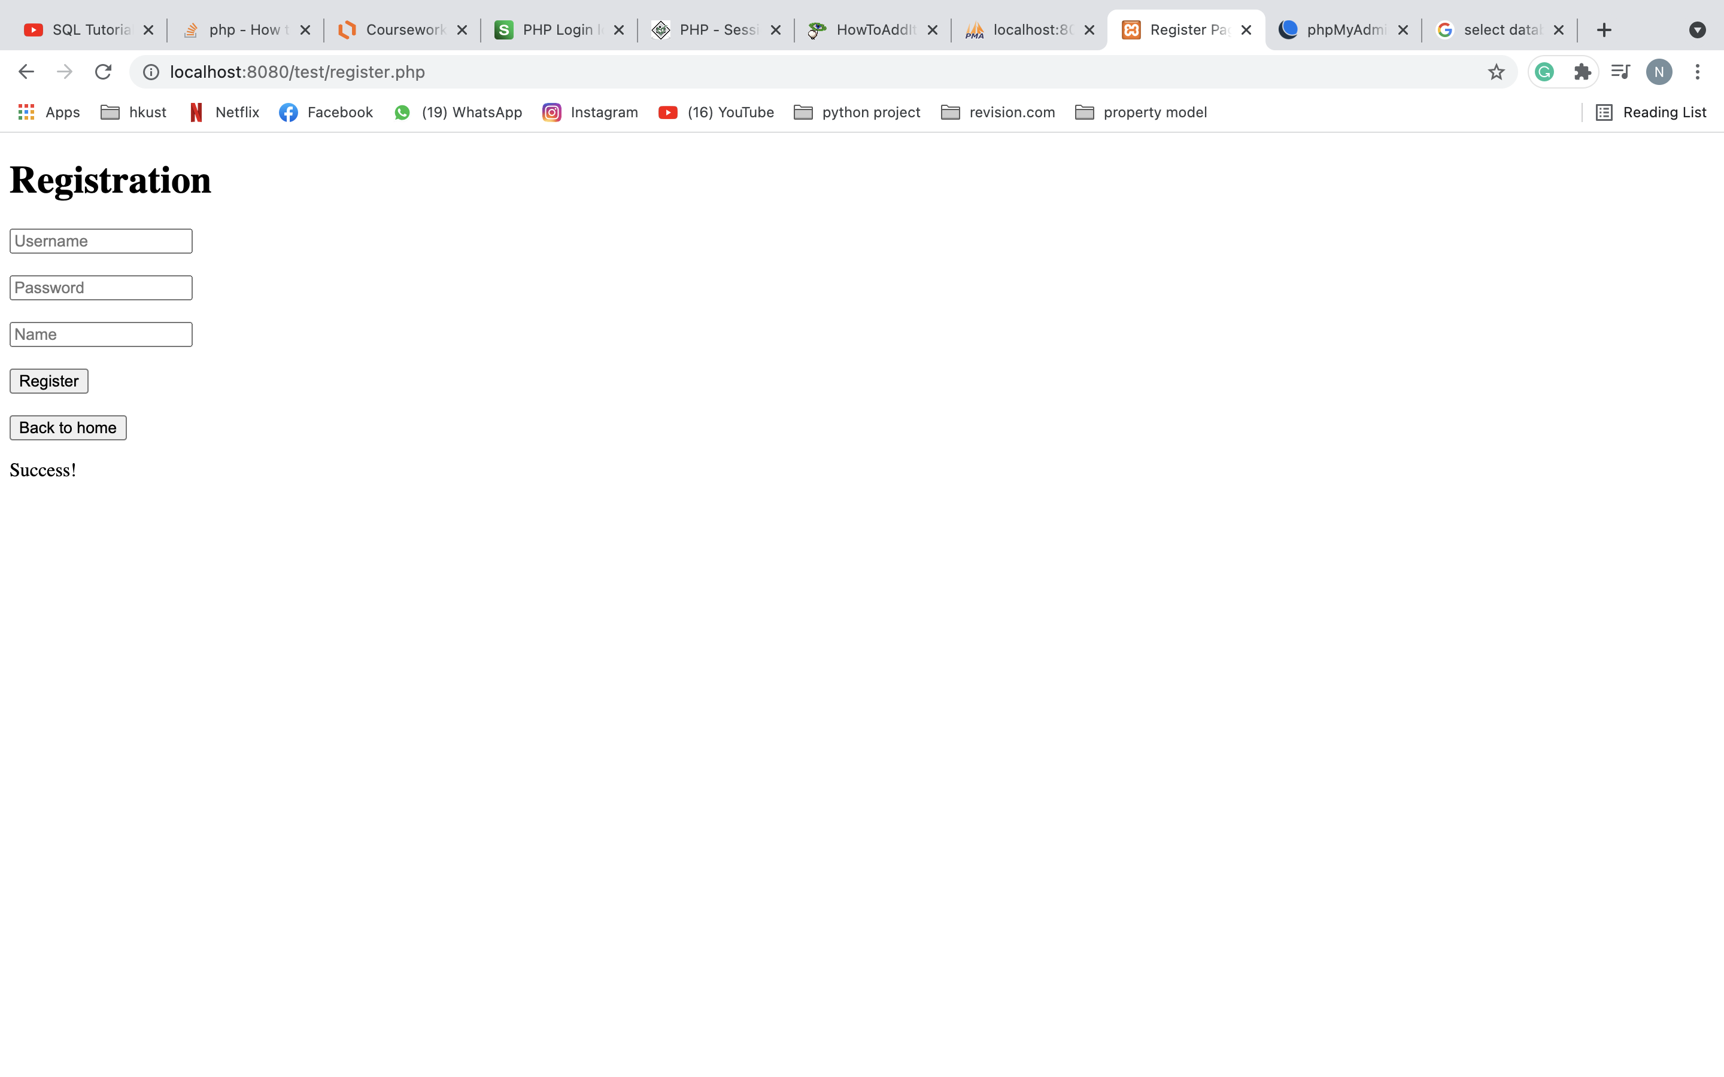

**2.1.3 Login page(login.php)**

This is the page directed after you click ‘Login’ in first page. This is the page for student to login. You can type your username and password and click ‘Login’ button to login to your account. If you want to return to first page you can press the ‘Back to Home Page’ button.

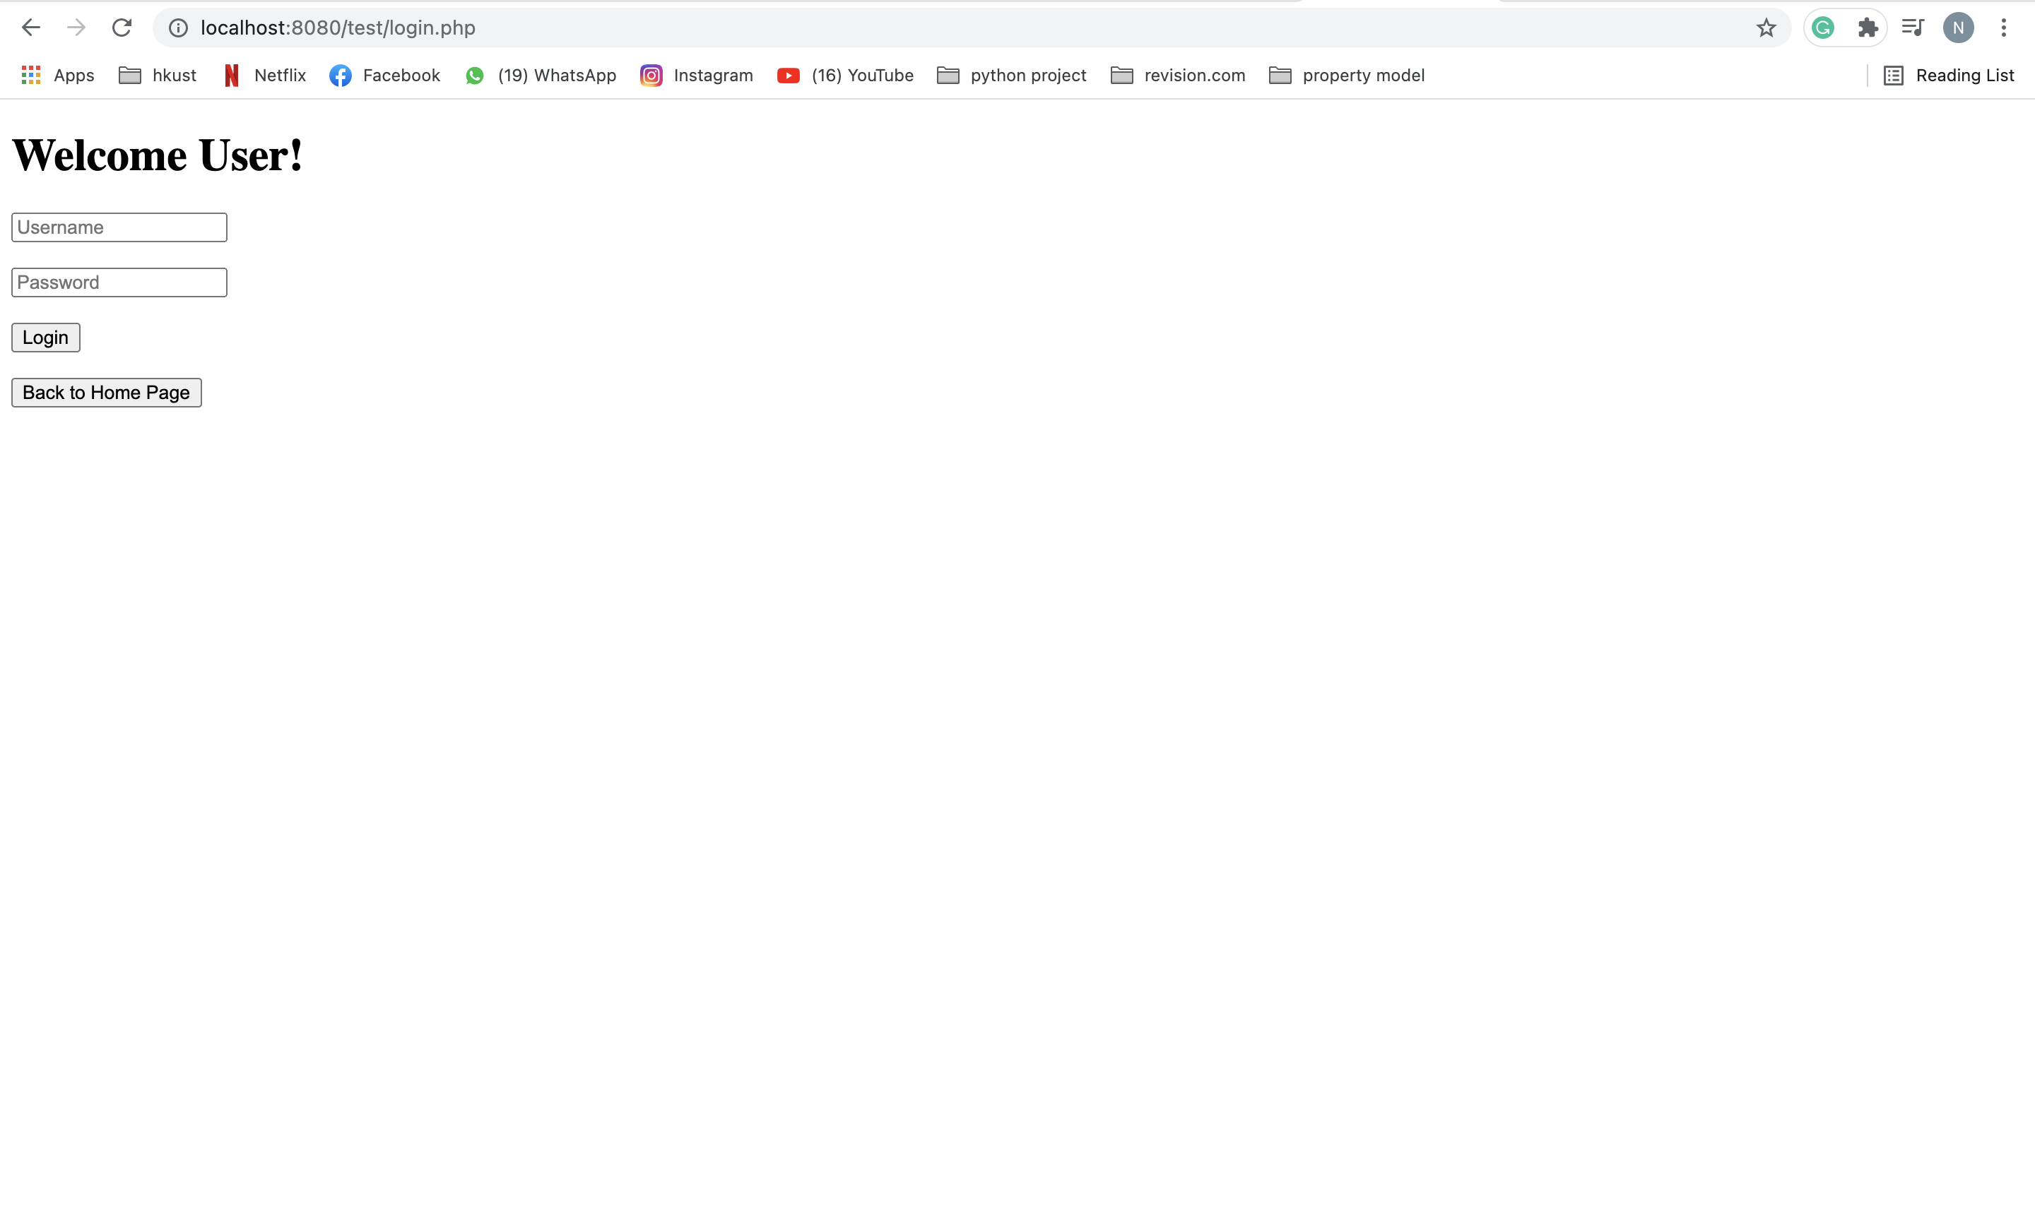

**2.1.4 Student home page(homepage.php)**

This is the page directed after student successfully login in login page. This is the page for student to select quizzes to do, view his records and logout. Student can click the ‘Select button’ below a quiz to select that quiz to do. Only quizzes which are available to student will show in here. Student can only do a quiz 1 time and if student select the same quiz to do it will pop a ‘You have token the quiz already!!!’ at the bottom of the page (See photo 2). Student can click the ‘Records’ button to view his past records. Student can click the ‘Logout’ button to logout your account. It will direct you back to the first page

**Photo 1**

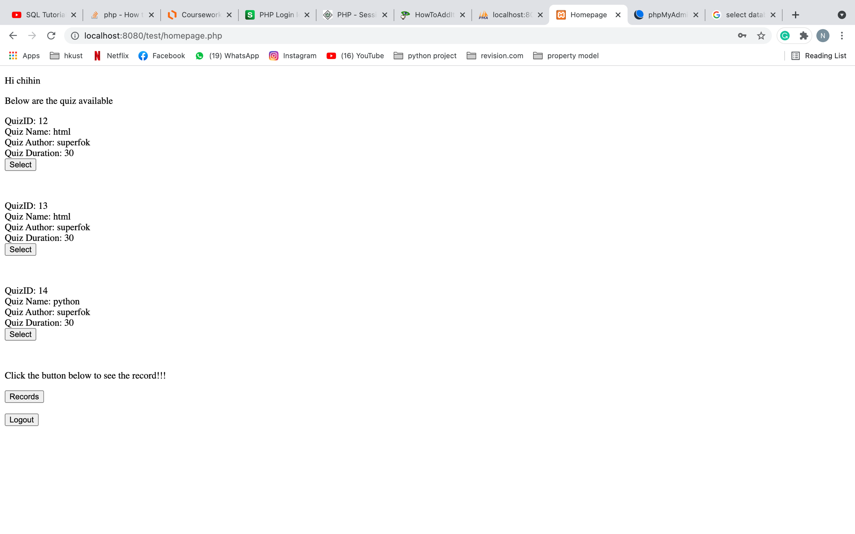

**Photo 2**

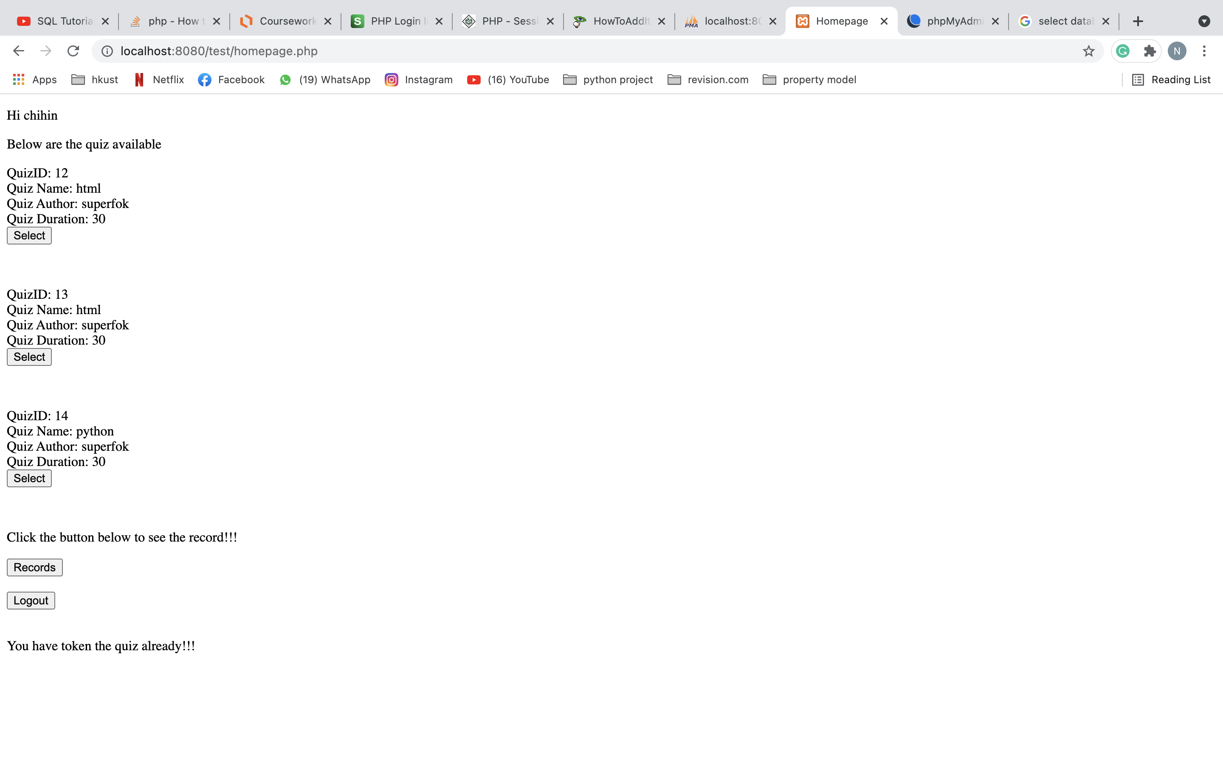

**2.1.5 Quiz page(quiz.php)**

The is the page after you select a specific quiz to do. You can finish the quiz here. After you have selected all the answer you can click the ‘submit’ button.

**Photo 1**

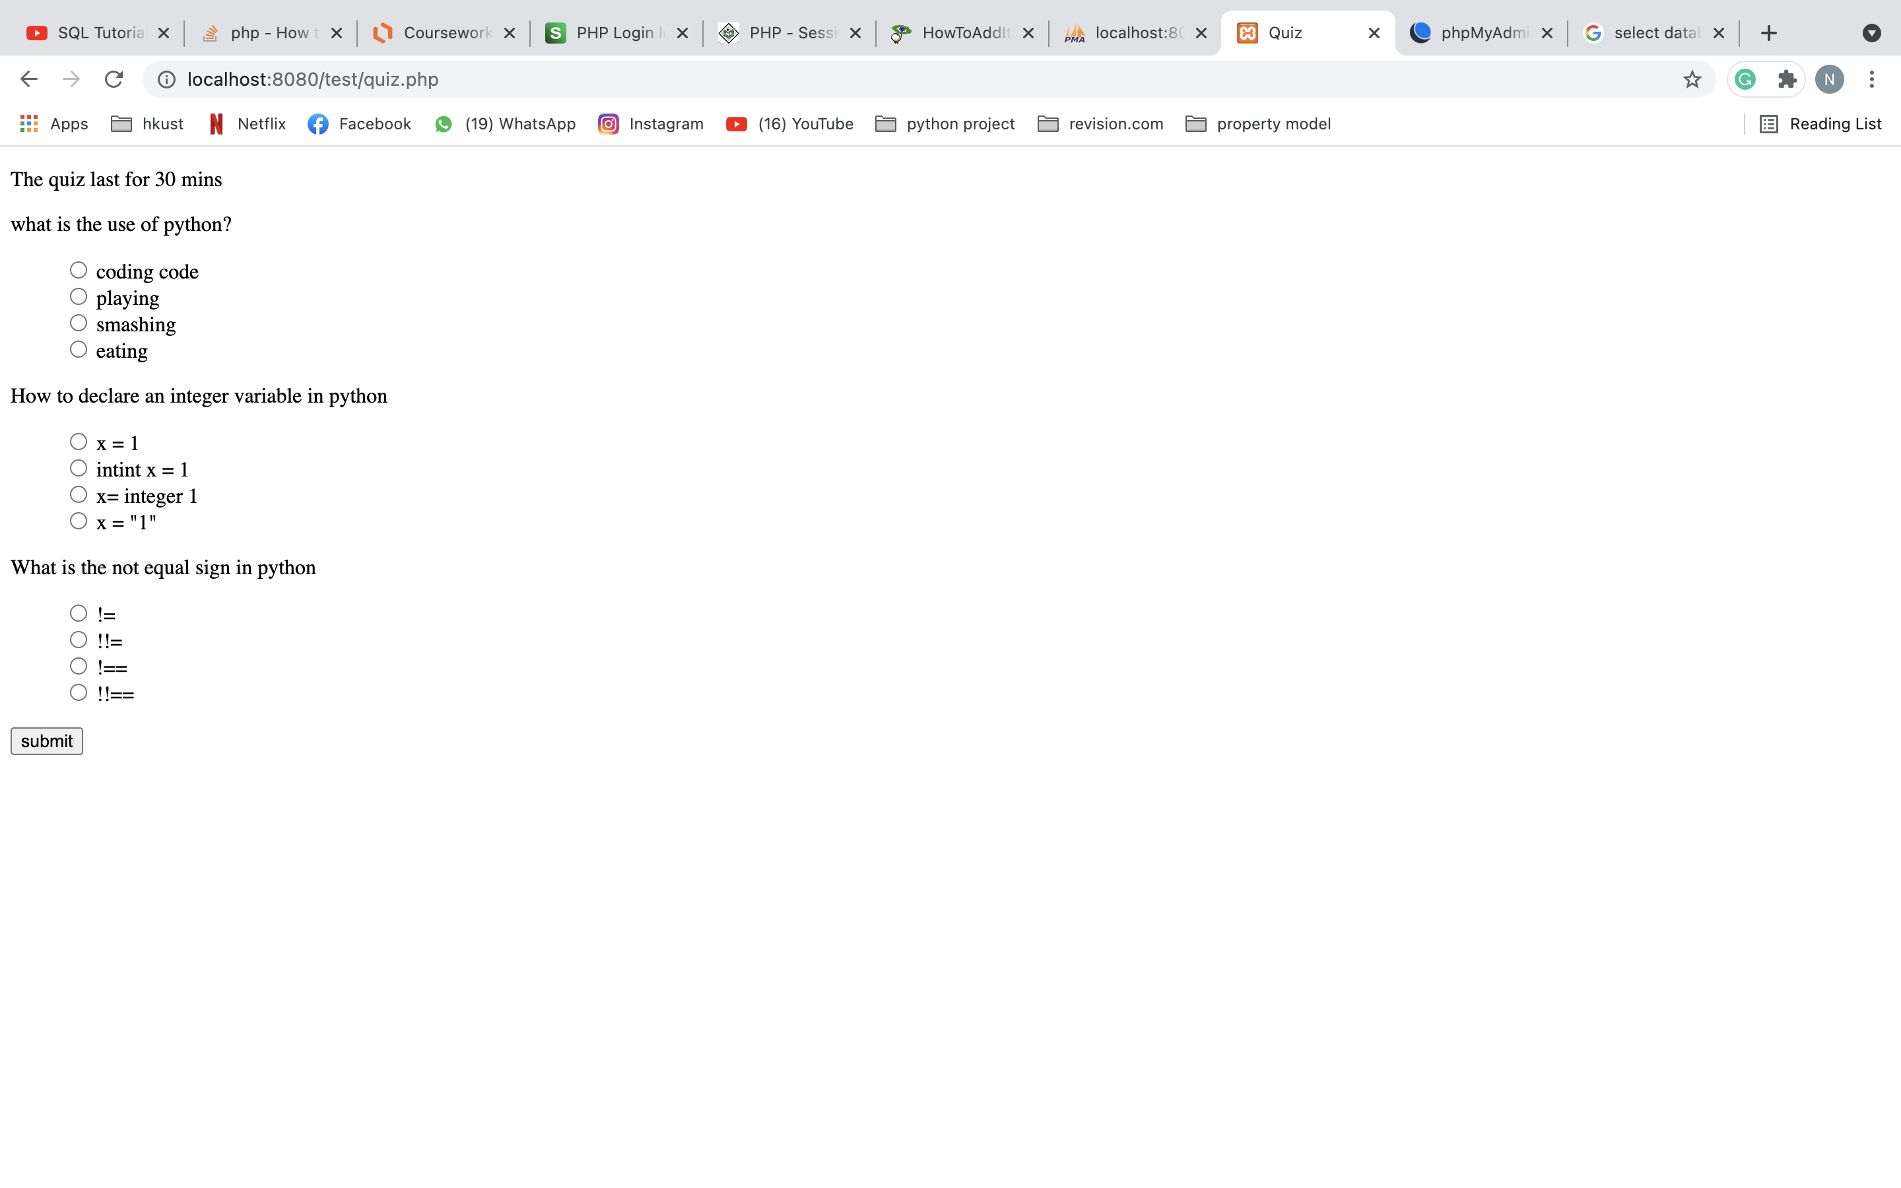

**Photo 2**

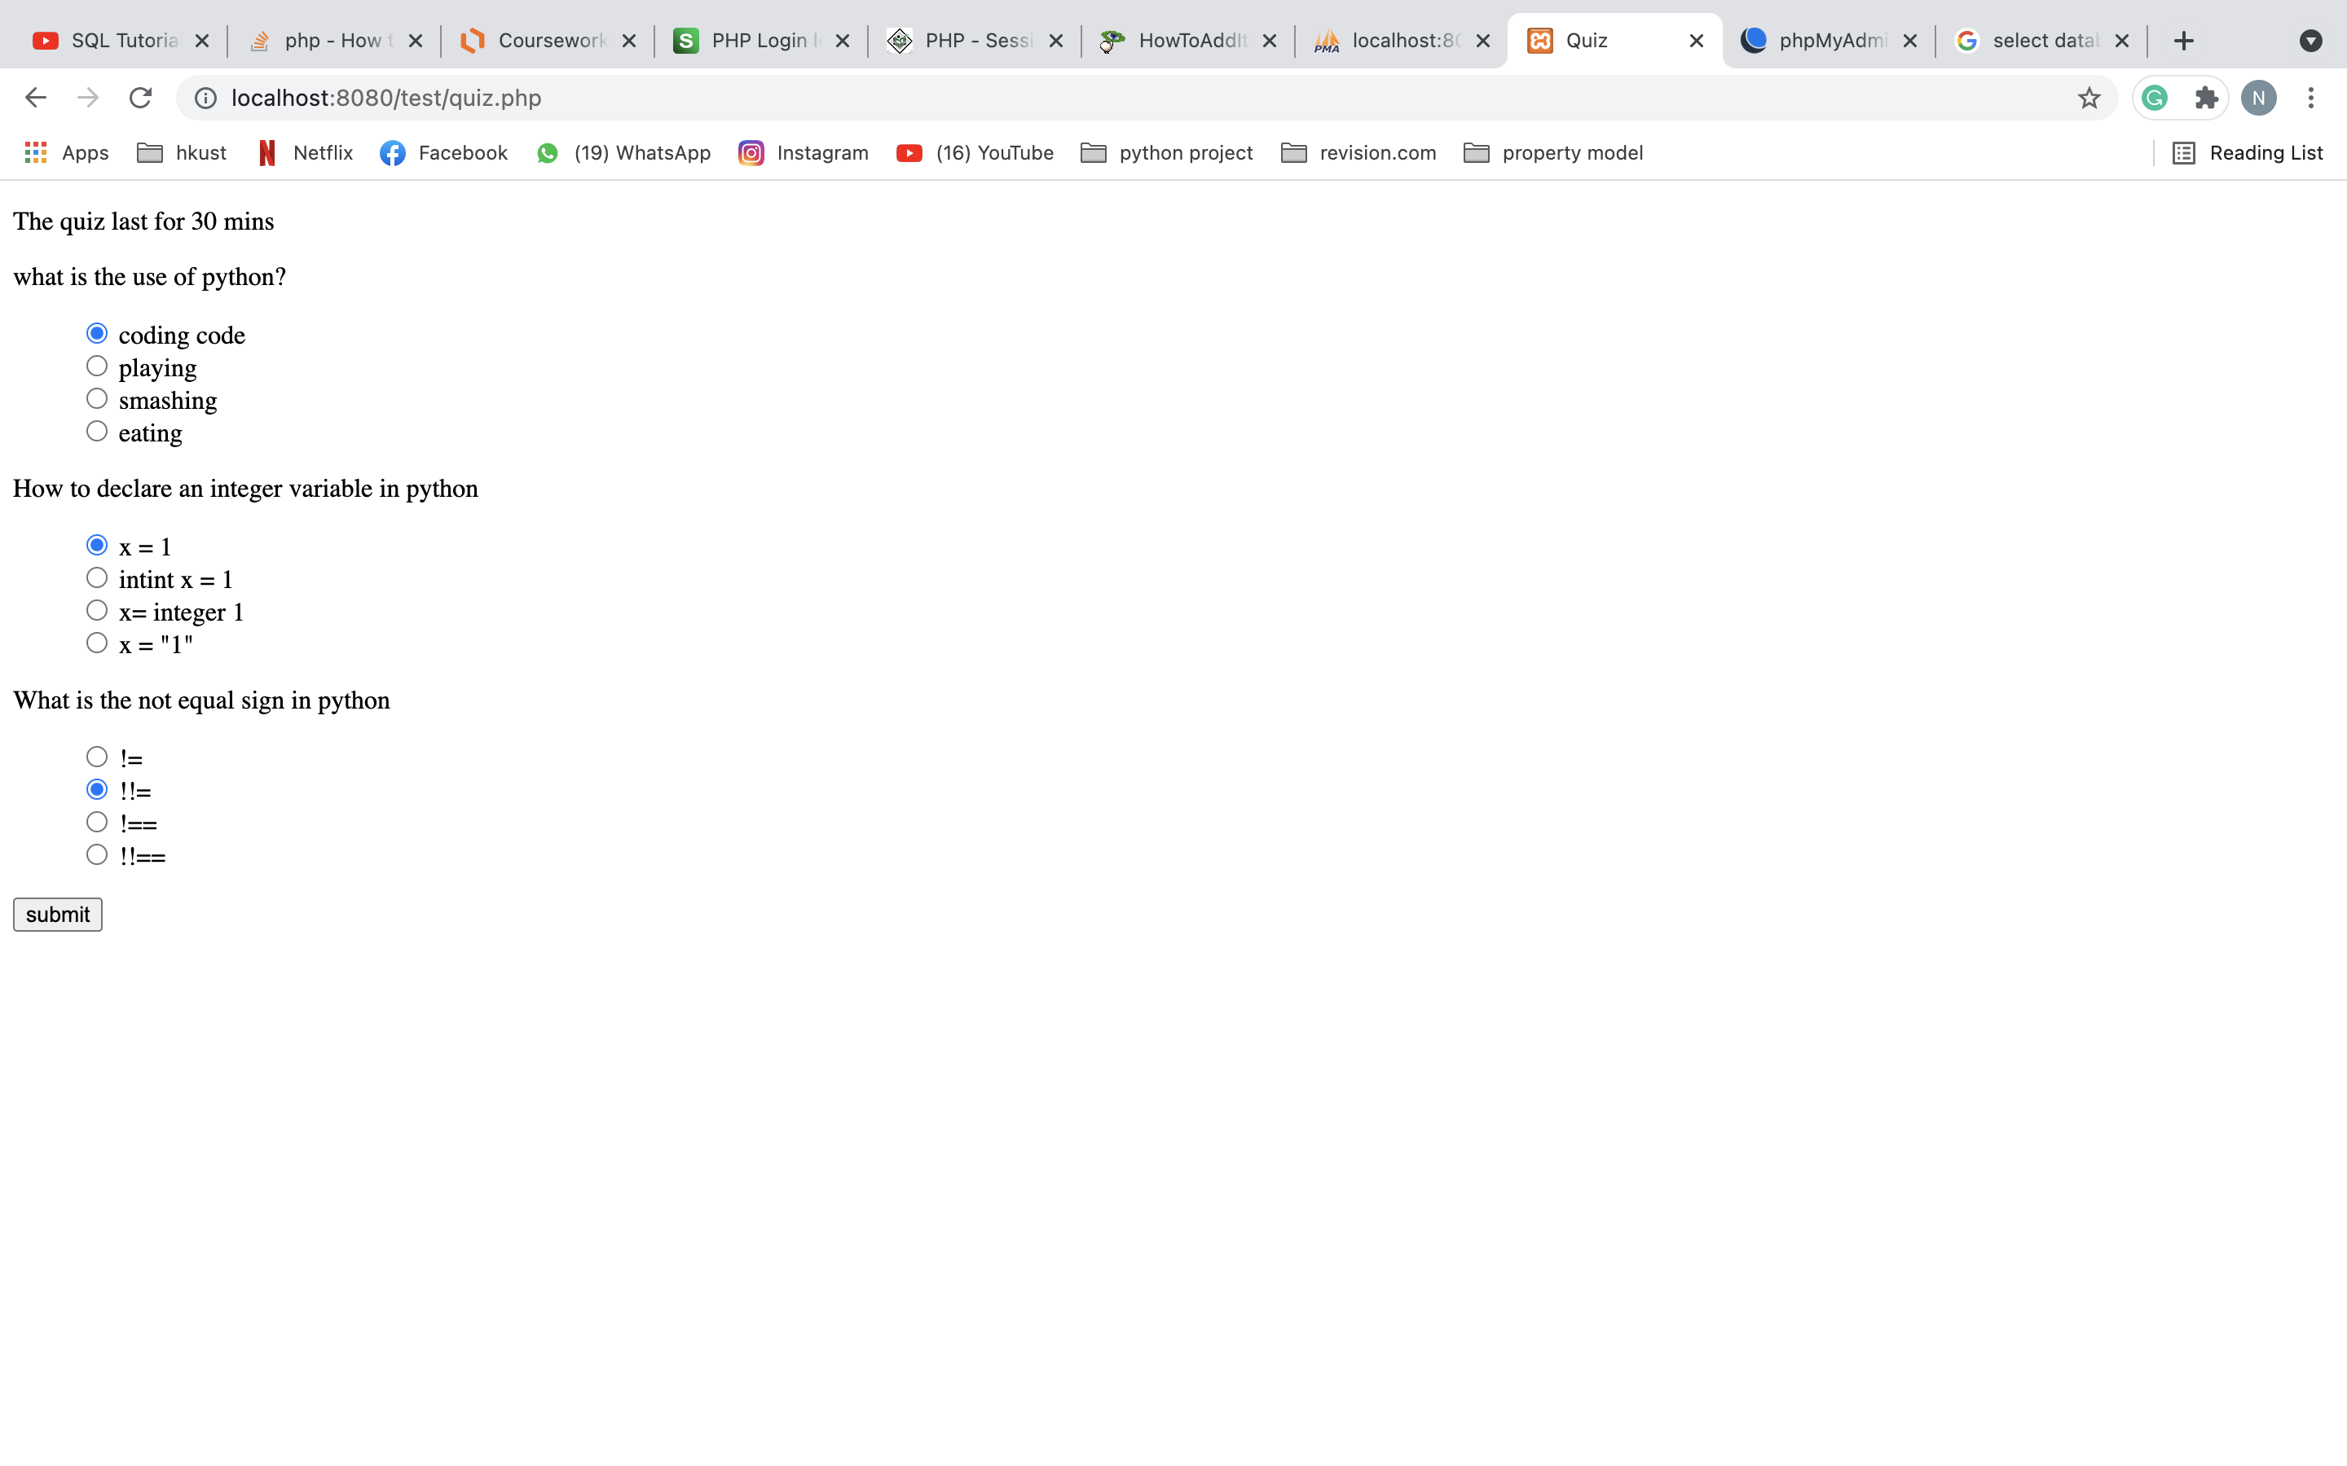

**2.1.6 Mark page(singleResult.php)**

Student will be directed to this page after he clicked the ‘submit’ button when he finished the quiz. Student will get the result of this quiz. Student can click the ‘Back to Home Page’ button to return to student home page.

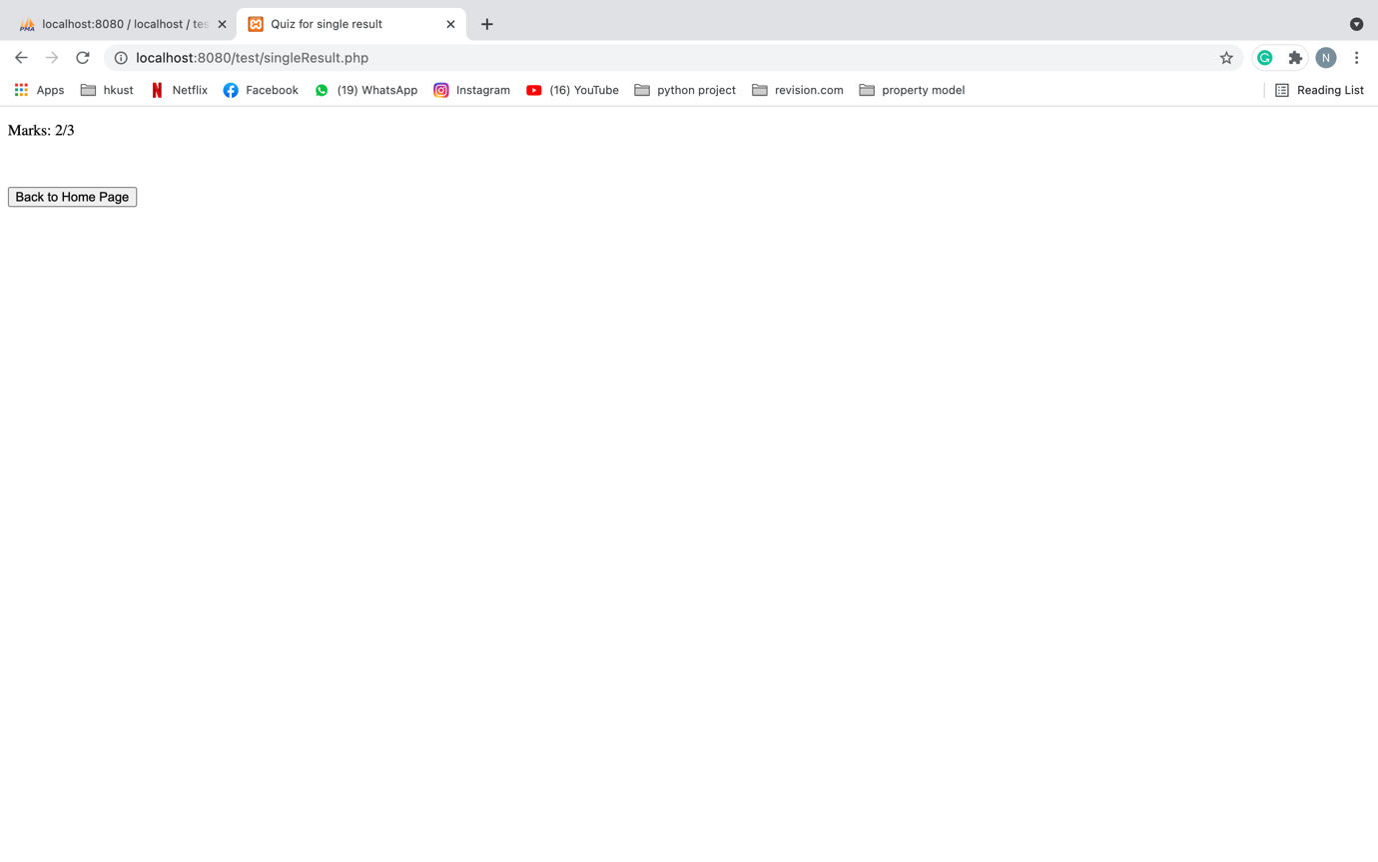

**2.1.7 Record page(record.php)**

Student will be directed to this page after he clicked the ‘Records’ button in student home page. Here will show all the record of the student like the quizID he has took, date of taking the quiz and the mark he got. Student can click ‘Back to Home Page’ to return to student home page.

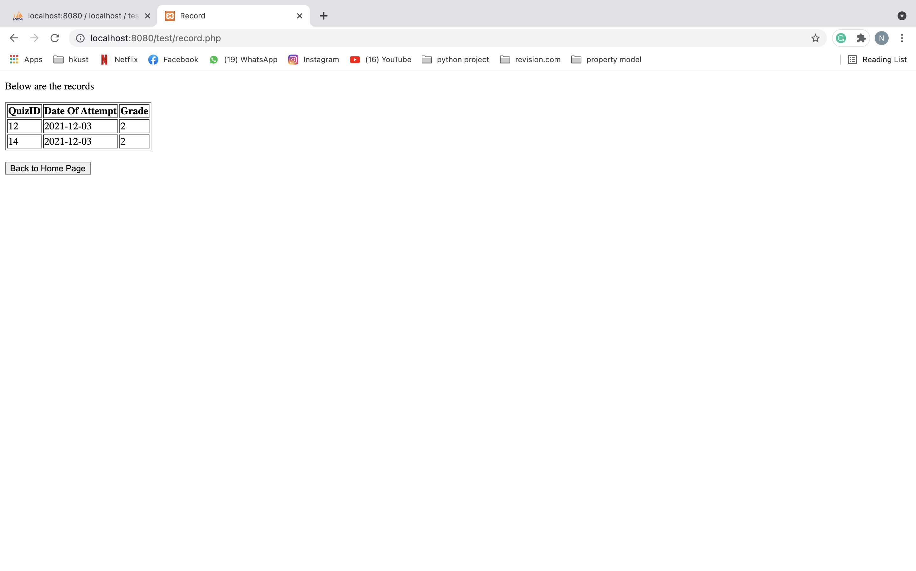

**2.2 Staff user**

**2.2.1 Staff login page(stafflogin.php)**

Staff will be directed to this page after clicking ‘Staff Login’ button in first page. This is the page for staff to login. Staff can type his username and password and click ‘Login’ button to login to his account. If you want to return to first page you can press the ‘Back to Home Page’ button.

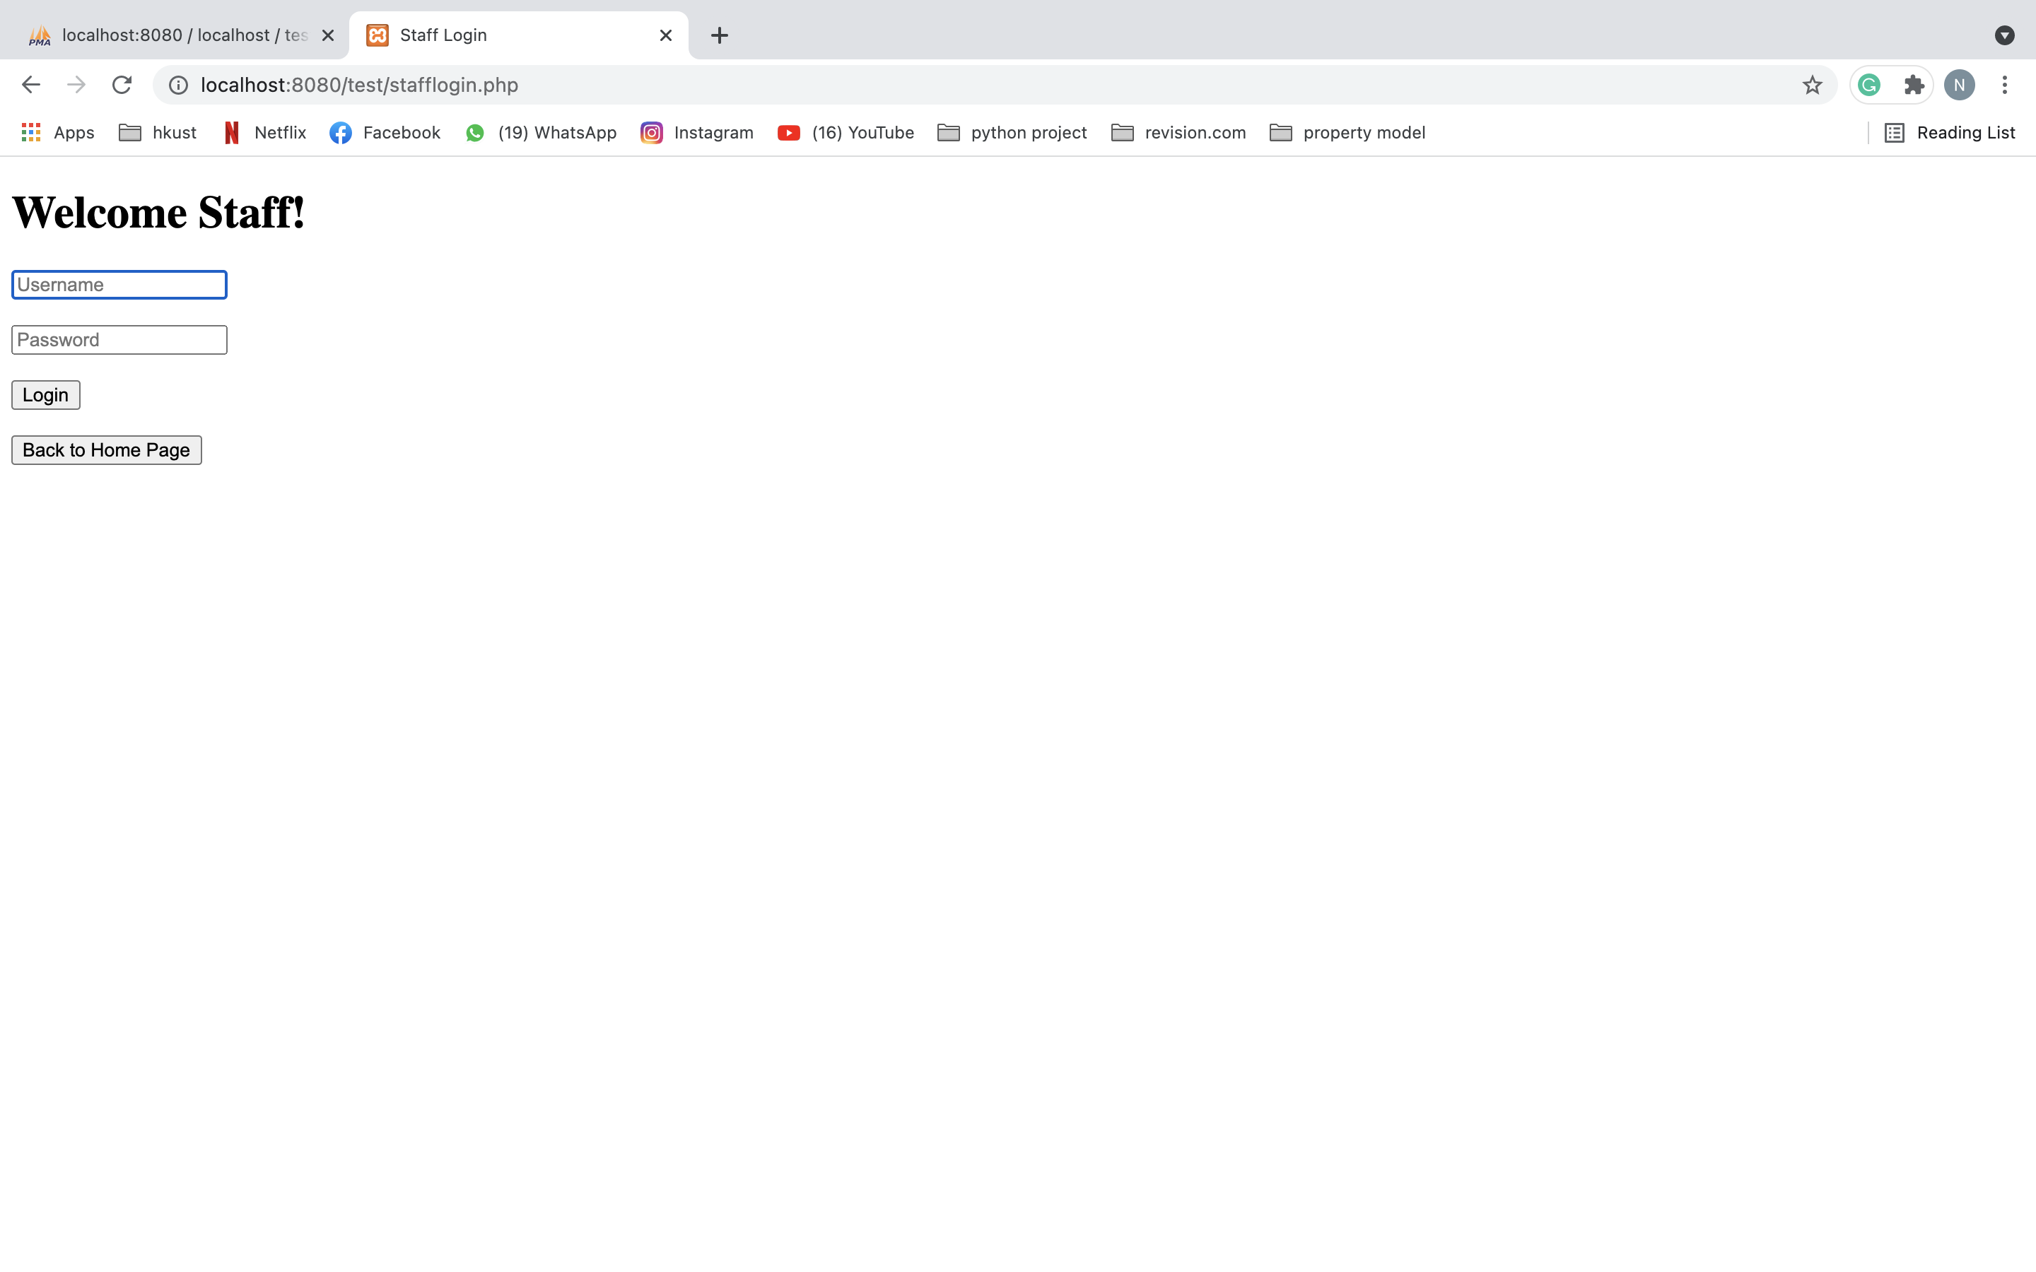

**2.2.2 Staff home page(staffHomePage.php)**

This is the page directed after staff successfully login in login page. This is the page for staff to create quiz, update and delete a quiz/question and logout. Staff can click the ‘Create a quiz!’ button to create a quiz. Staff can click the ‘Update a quiz!’ button to update a quiz. Staff can click the ‘Delete a quiz/question!’ to delete a quiz/question. Staff can click the ‘Logout’ button to logout his account. It will direct staff back to the first page.

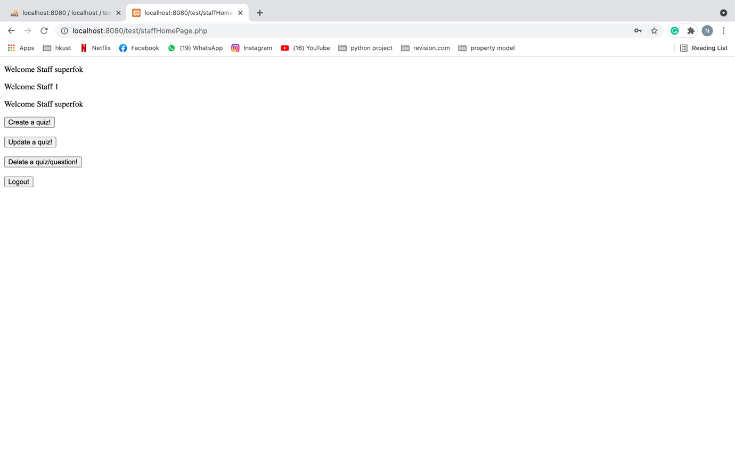

**2.2.3 Create quiz page(insertquiz.php)**

This is the page directed after staff clicked ‘Create a quiz!’ in staff home page. This is the page for staff to create quiz. Staff can type the quiz name, quiz duration (should be longer than 10 minutes), and choose whether it is available to user. After finishing, staff can click the ‘Submit’ button to create the quiz. Staff can click the ‘Back to Home Page’ button to return to staff home page.

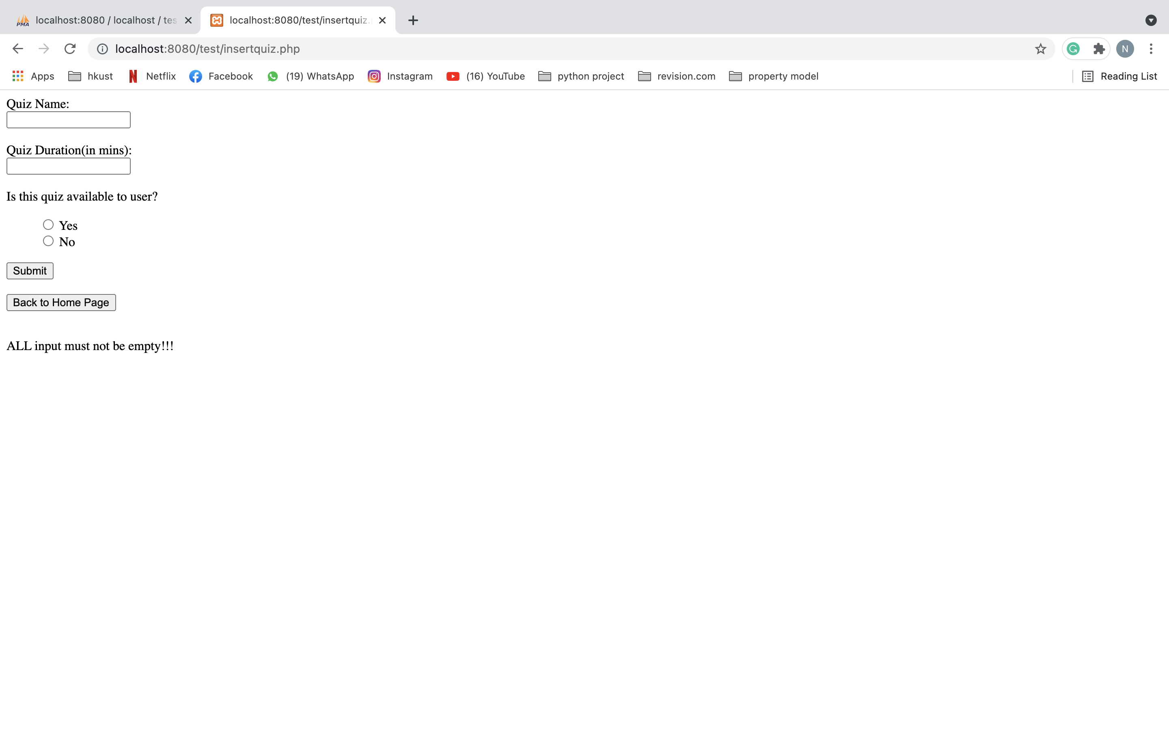

**2.2.4 Create question page(insertquestion.php)**

This is the page directed after staff clicked ‘Submit’ in create quiz page. This is the page for staff to create question. Staff can type the question name, choices, and answer. Remember all input should not be empty and the input of the answer should be the same of one of the choices. After finishing, staff can click the ‘Add Question’ button to add question. Staff can continue adding questions in this page for the quiz. Staff can click the ‘Back to Homepage’ button to return to staff home page.

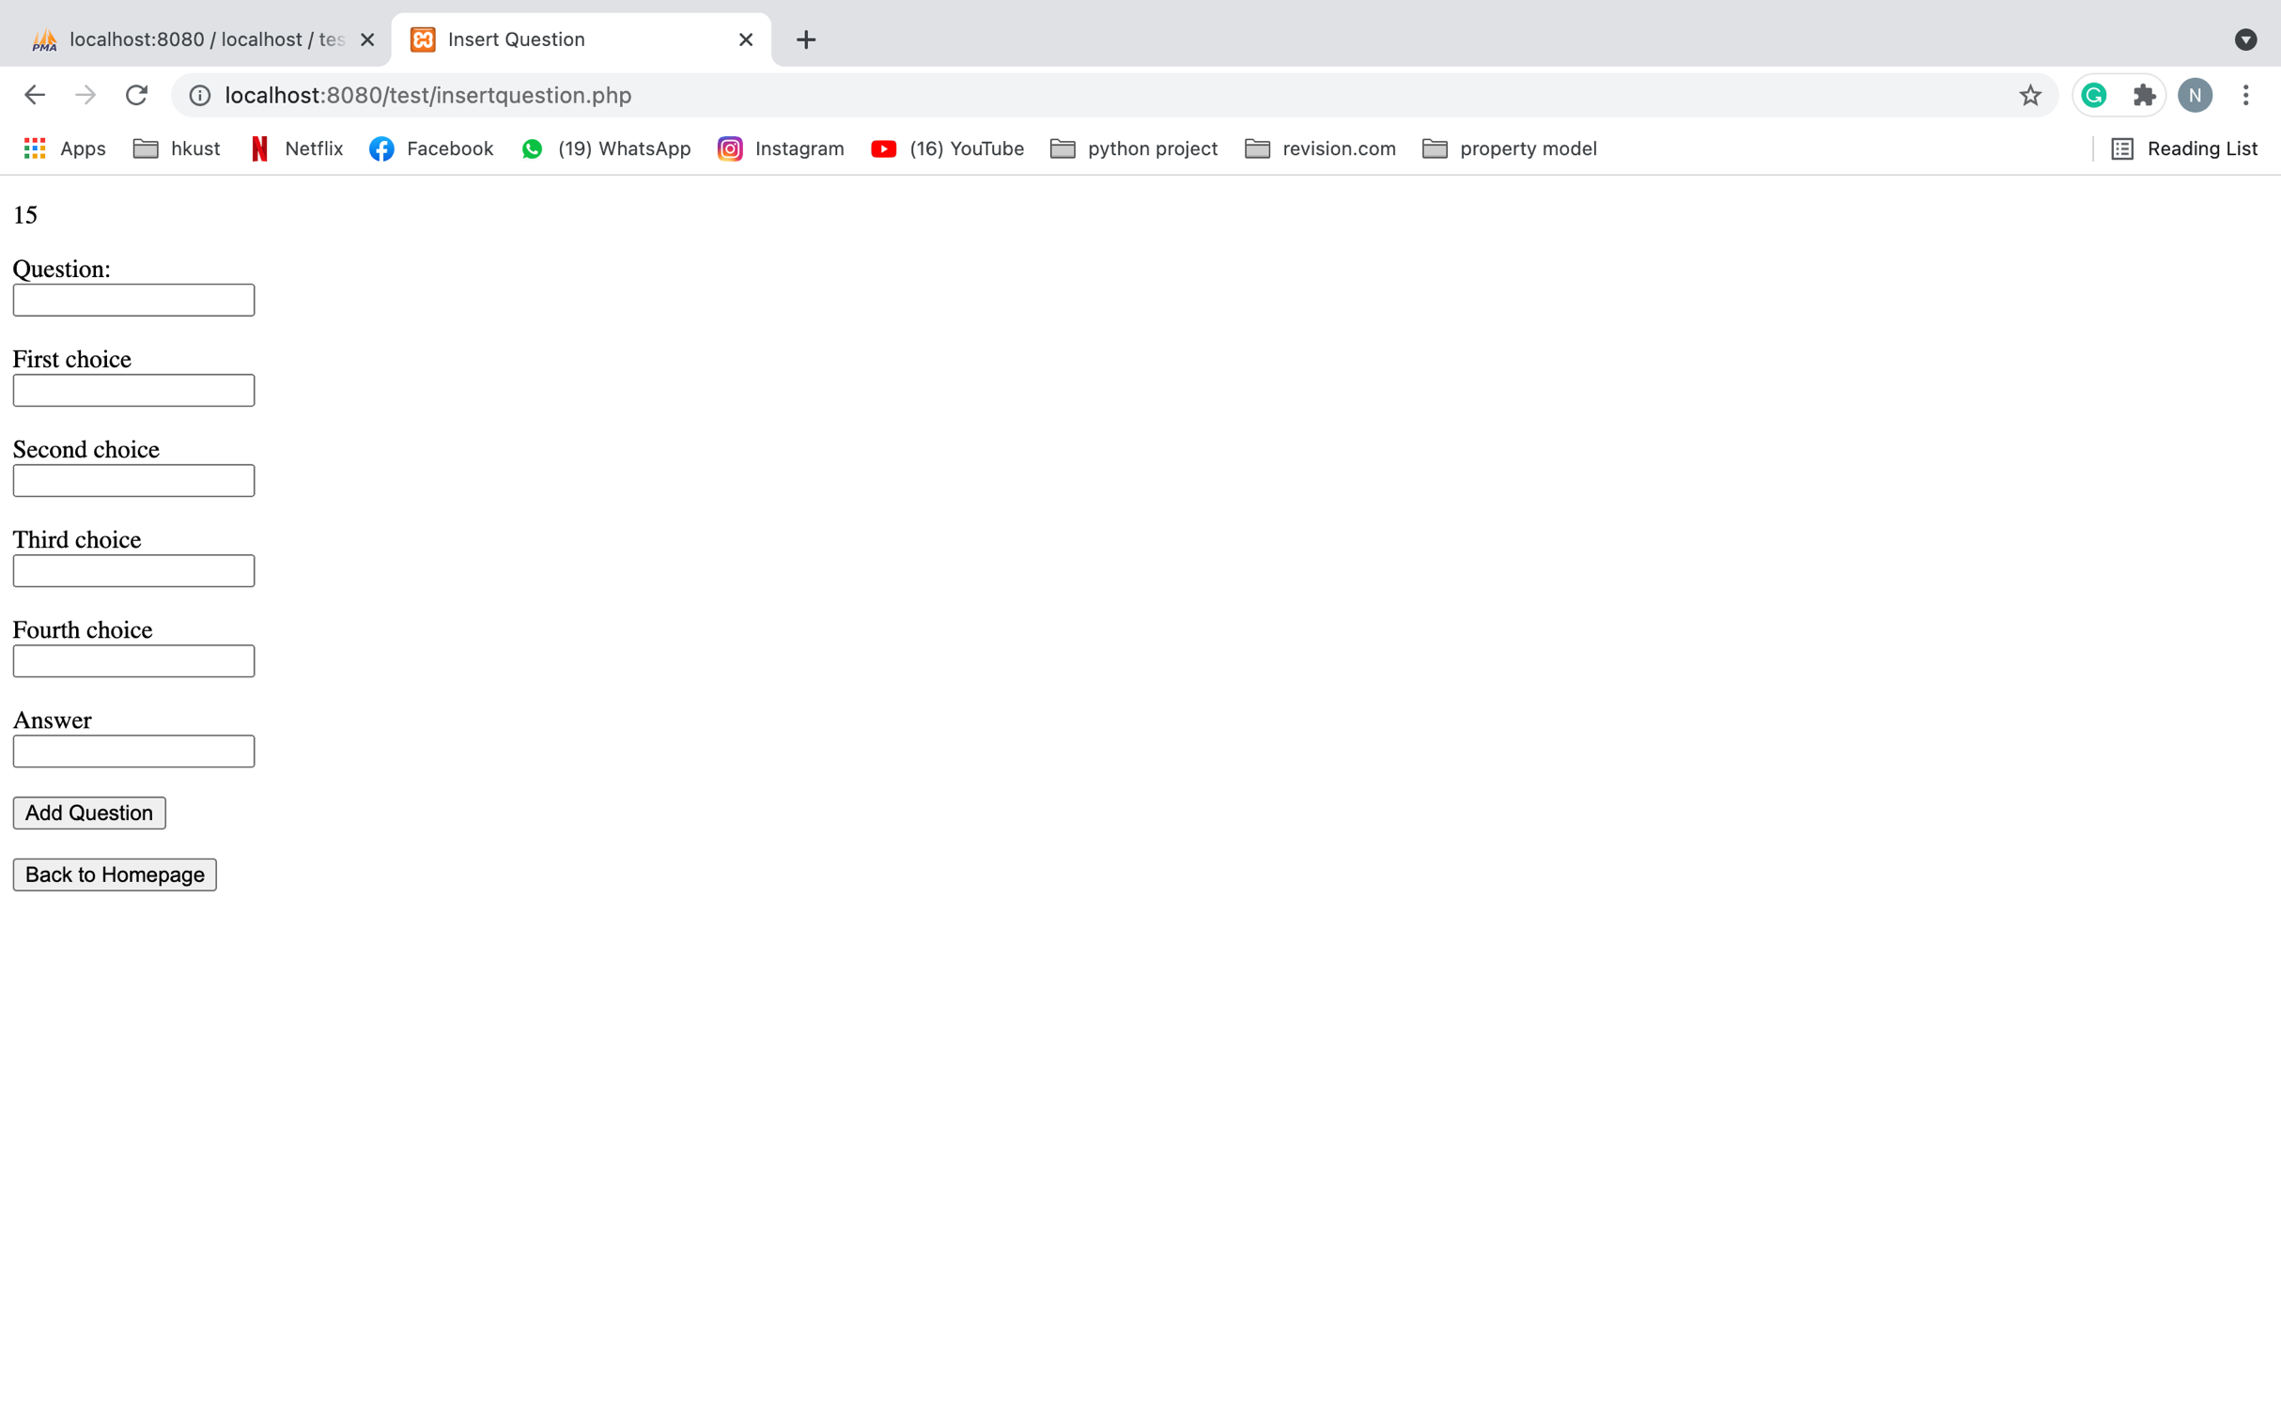

**2.2.5 Update quiz page(update.php)**

This is the page directed after staff clicked ‘Update a quiz!’ in staff home page. This is the page for staff to update quiz. All quiz will be shown from the database and staff has 3 options to use. If staff want to update the quiz detail only like changing quiz name and duration, he can click the ‘Click to Update Quiz’ button. If staff want to update the question detail like changing answer, he can click the ‘Click to Update Question’ button. If staff want to add question, he can click the ‘Click to Add Question’ button. Staff can click the ‘Back to Home Page’ button to return to staff home page.

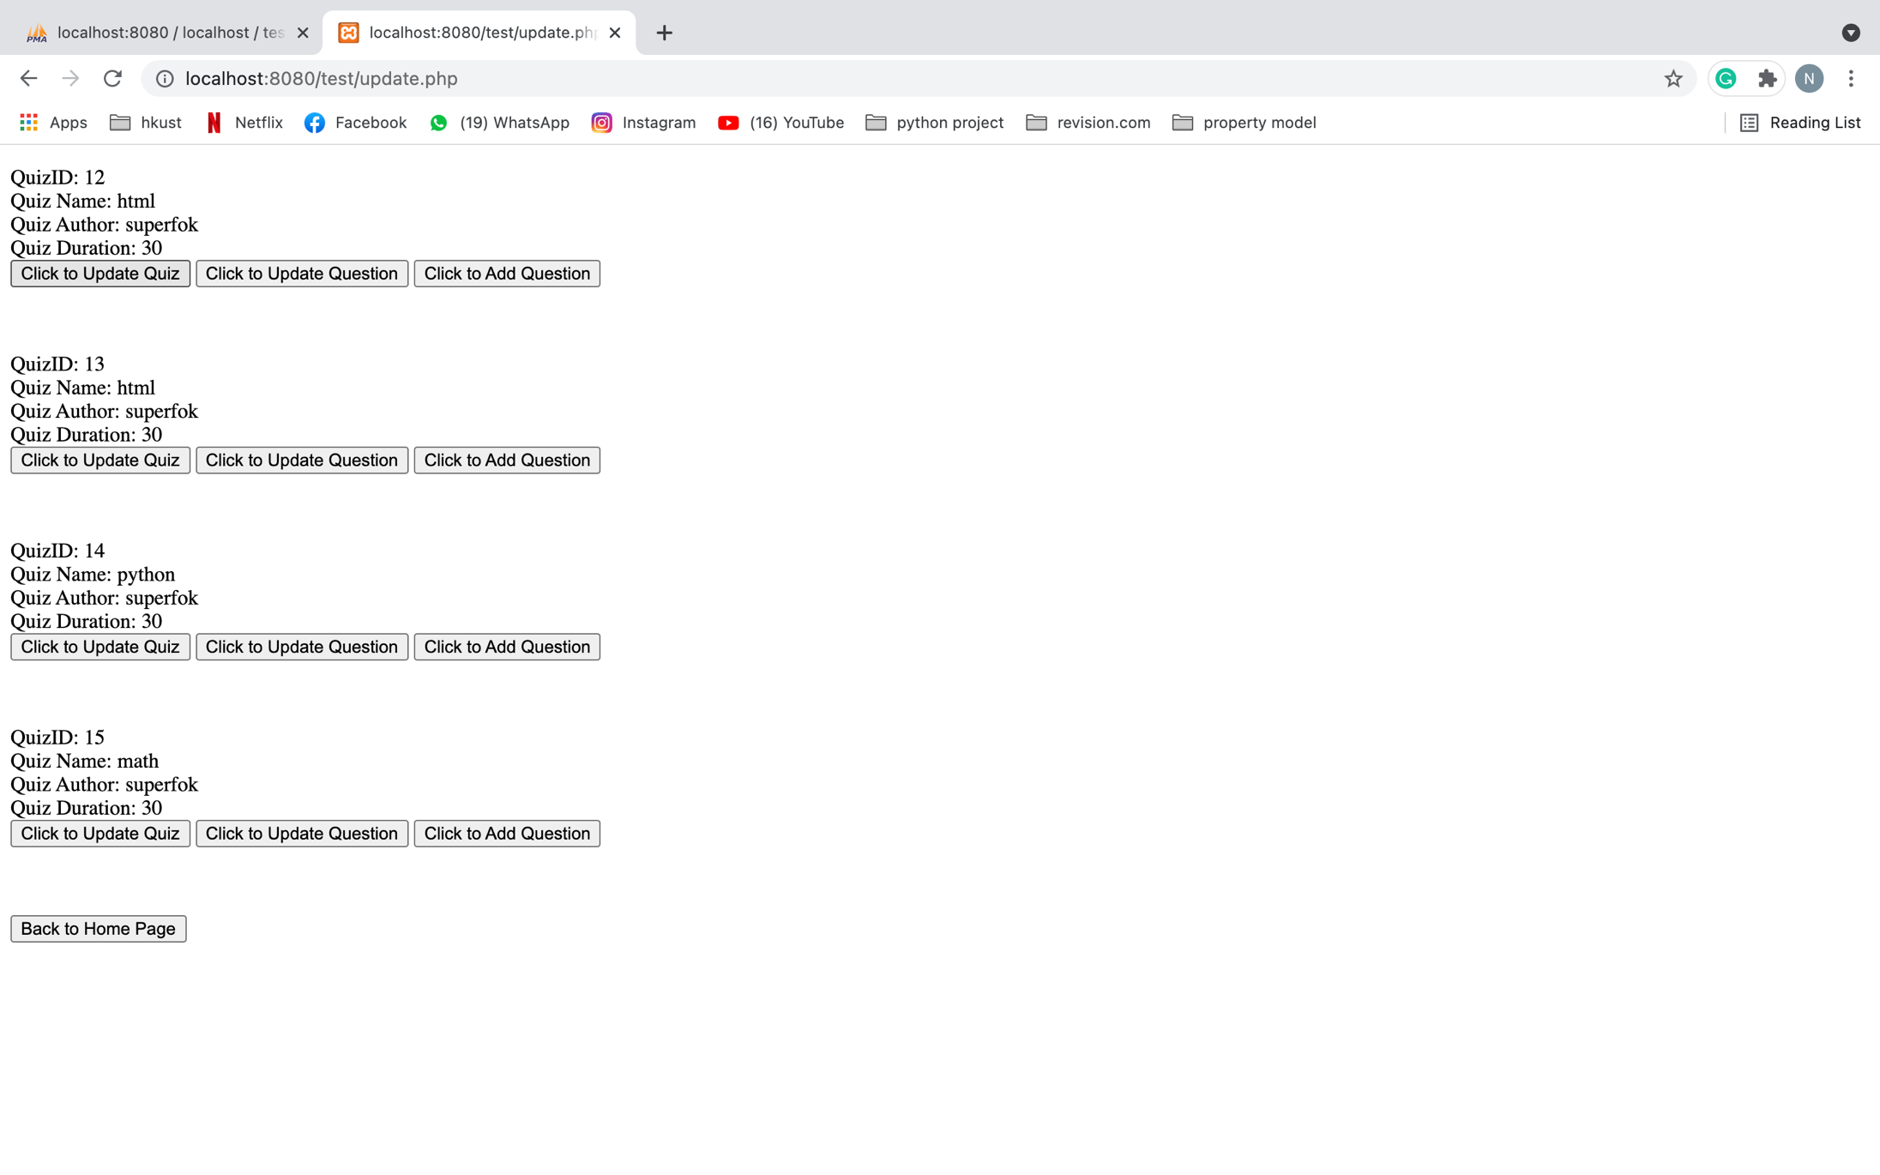

**2.2.6 Update quiz detail page(updatequiz.php)**

This is the page directed after staff clicked ‘Click to Update Quiz’ button in update quiz page. This is the page for staff to update quiz detail. Staff can change the detail of the quiz and left the input empty if he doesn’t want to change some input. Staff can click the ‘Back to Home Page’ button to return to staff home page.

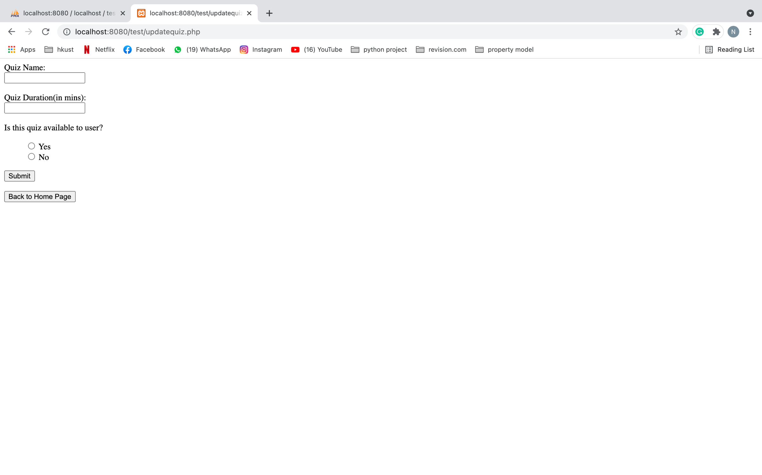

**2.2.7 Update question detail page (updatequestion.php)**

This is the page directed after staff clicked ‘Click to Update Question’ button in update quiz page. This is the page for staff to update question detail. Staff can choose the question he wants to edit and he will have 3 options. If staff want to update the question name, he can click the ‘Update Question’ button. If staff want to update the choices, he can click the ‘Update Choice’ button. If staff want to update the answer, he can click the ‘Update Answer’ button. Staff can click the ‘Back’ button to return to update quiz page.

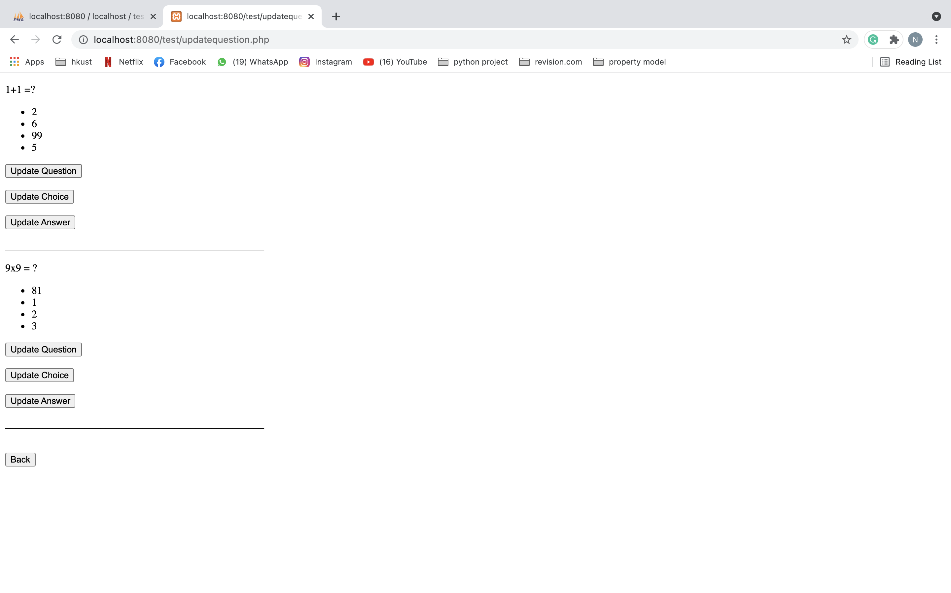

**2.2.8 Update question name page (updatequestiondetail.php)**

This is the page directed after staff clicked ‘Update Question’ button in update question detail page. This is the page for staff to update the name of the question. Staff can input the new question name and click ‘Update Question’ button. There will be a ‘Success!!!!’ message if the question name is updated successfully (See photo 2). Staff can click the ‘Back’ button to return to update question detail page.

**Photo 1**

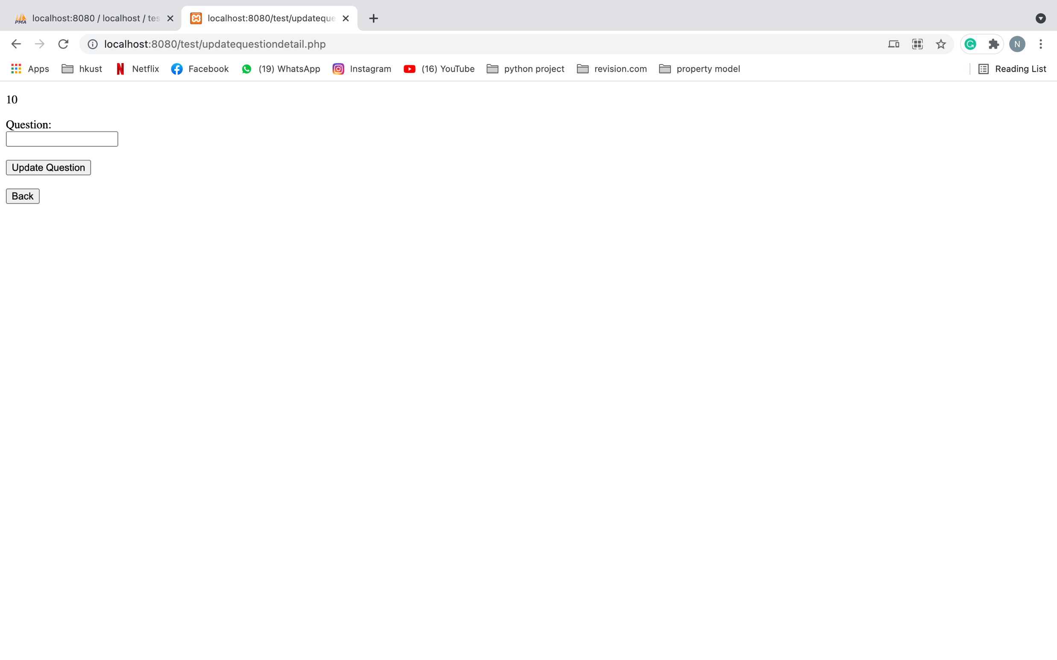

**Photo 2**

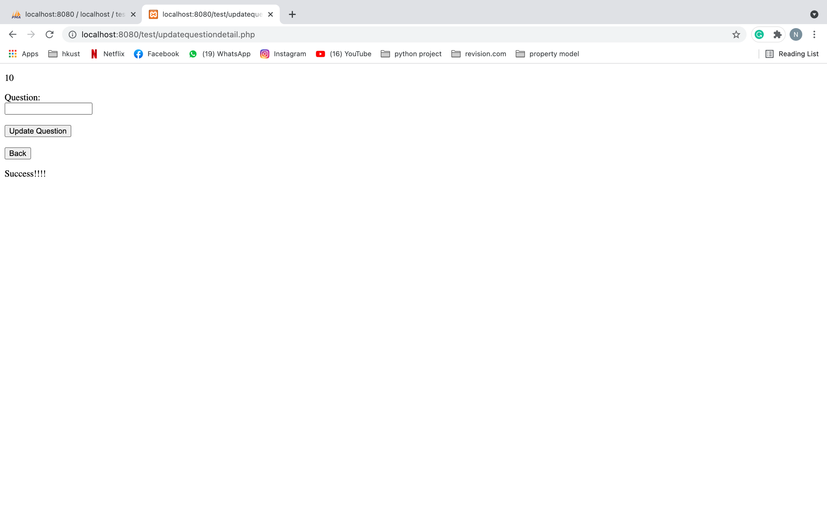

**2.2.9 Update question choice page (updatechoicedetail.php)**

This is the page directed after staff clicked ‘Update Choice’ button in update question detail page. This is the page for staff to update the choice of the question. Staff can choose to update all or some of the choices. Staff should leave the choice which he doesn’t want to edit as empty. After finishing, staff can click the ‘Update Choice’ button to update choice. There will be a ‘successfully update choice’ + ‘(the choice you are updating)’ message if the choices are updated successfully (See photo 2). Staff can click the ‘Back’ button to return to update question detail page.

**Photo 1**

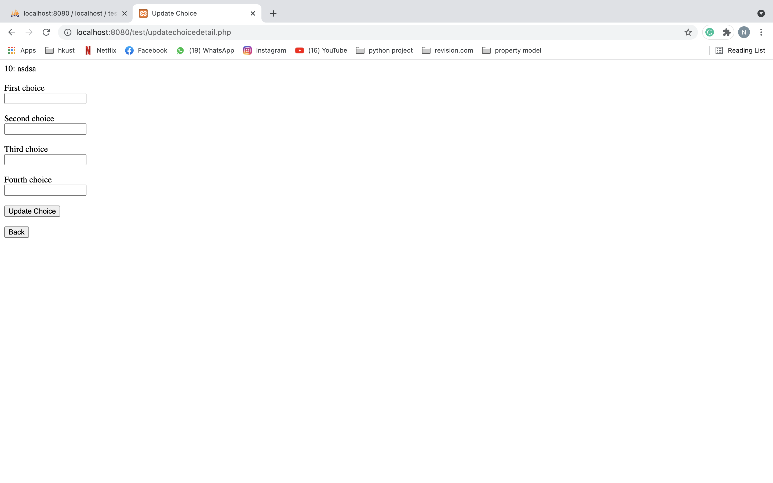

**Photo 2**

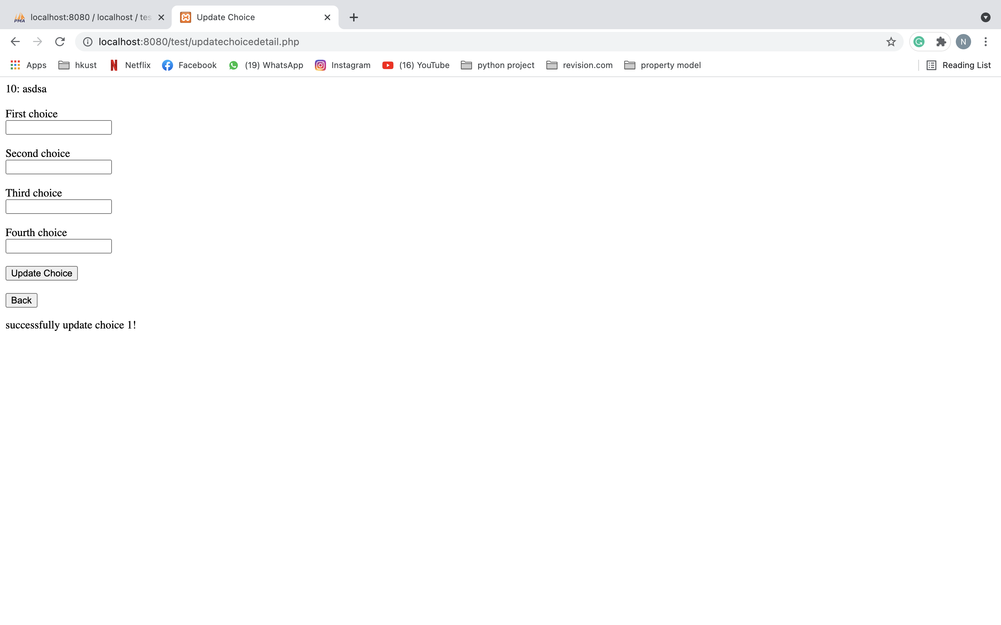

**2.2.10 Update question answer page (updateanswer.php)**

This is the page directed after staff clicked ‘Update Answer’ button in update question detail page. This is the page for staff to update the answer of the question. Staff can input the new answer which must be same as 1 of the choices and click ‘Update Answer’ button. There will be a ‘successfully change non answer!’ and ‘successfully update answer!’ messages if the question answer is updated successfully (See photo 2). Staff can click the ‘Back’ button to return to update question detail page.

**Photo 1**

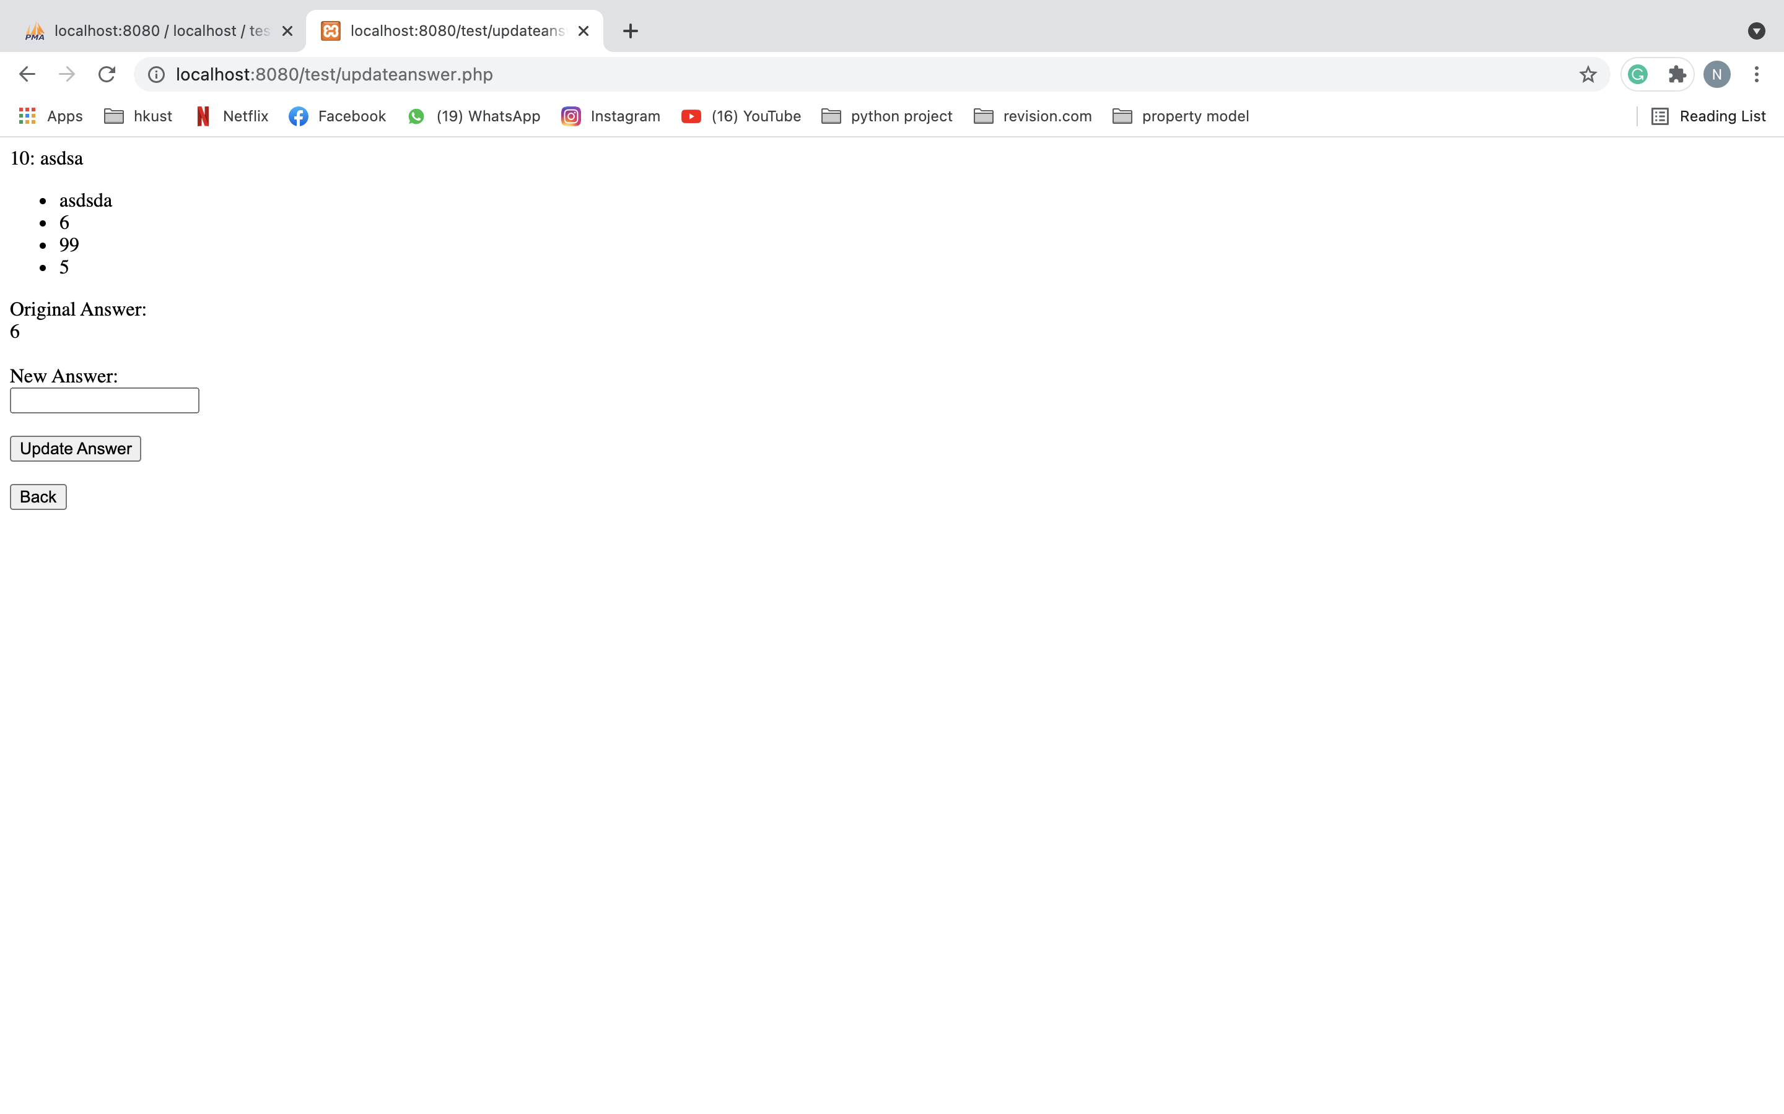

**Photo 2**

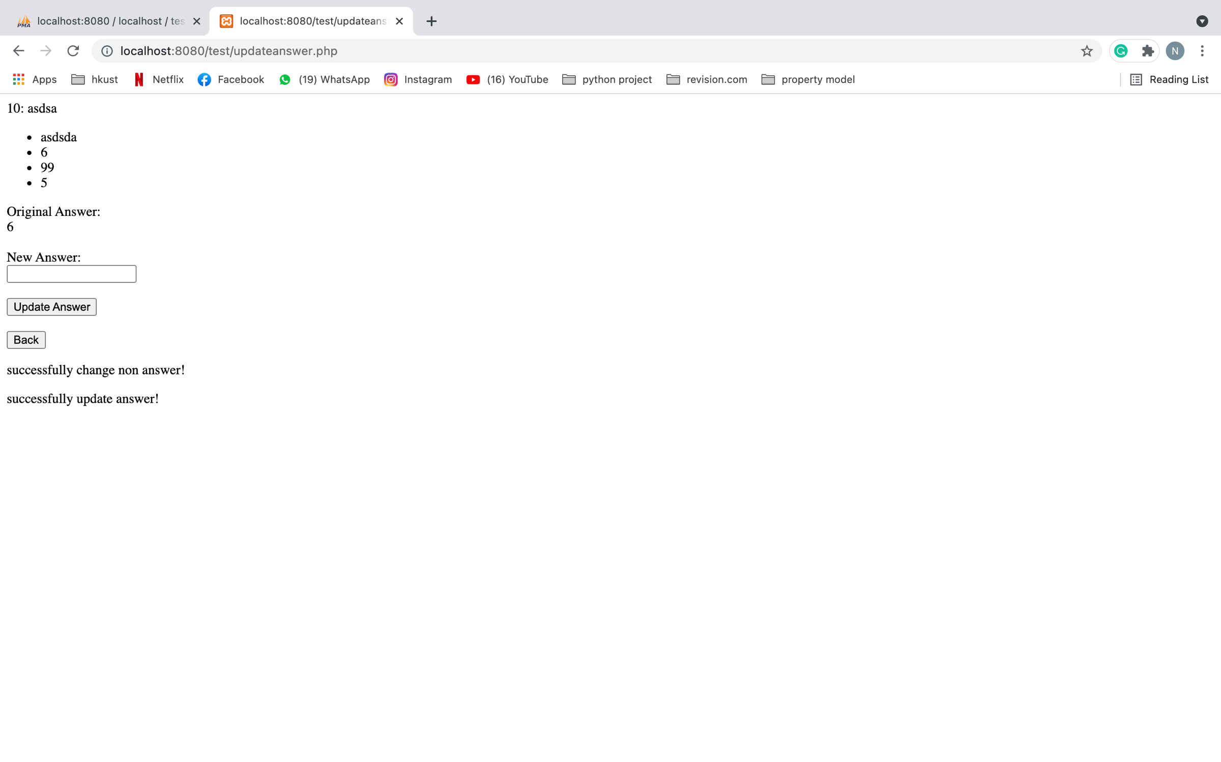

**2.2.11 Add question page (insertquestion.php)**

This is the page directed after staff clicked ‘Click to Add question’ button in update quiz detail page. This is the page for staff to add question. Staff can type the question name, choices, and answer. Remember all input should not be empty and the input of the answer should be the same of one of the choices. After finishing, staff can click the ‘Add Question’ button to add question. Staff can continue adding questions in this page for the quiz. Staff can click the ‘Back to Homepage’ button to return to staff home page.



**2.2.12 Delete quiz page (delete.php)**

This is the page directed after staff clicked ‘Delete a quiz/question!’ in staff home page. This is the page for staff to delete quiz. All quiz will be shown from the database and staff has 2 options to use. If staff want to delete the entire quiz, he can click the ‘Delete Quiz’ button. The database will update automatically and the quiz will disappear from the page. If staff want to delete the question from the quiz, he can click the ‘View to Delete Question’ button. Staff can click the ‘Back to Home Page’ button to return to staff home page.

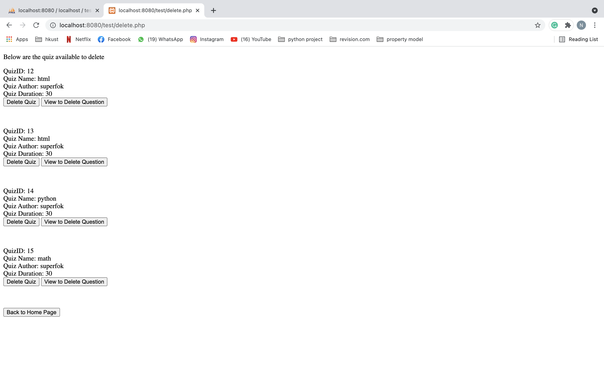

**2.2.13 Delete quiz page (deletequestion.php)**

This is the page directed after staff clicked ‘View to Delete Question’ in delete quiz page. This is the page for staff to delete questions from quiz. All question will be shown from the database and staff can click the ‘Delete’ button to delete specific question. The database will update automatically and the question will disappear from the page. Staff can click the ‘Back to Home Page’ button to return to staff home page.

